

**CSCI 5410**

**Serverless Data Processing**

**Assignment 4**

**Name : Sagarkumar Pankajbhai Vaghasia**

**CSID : vaghasia**

**Banner ID : #B00878629**

**Gitlab Link :**

**PART-A Use AWS Lambda-SQS-SNS.**

* First and foremost, I logged in AWS account through AWS academy student login. After log in, I selected the dashboard option from the left-hand side panel where a course is available under the name of “ALLFv1-17043”. Selecting the course took me to AWS Academy Learner Lab – Foundation Services page from which I selected “Modules” section which displayed three options. Amongst those options, selected “Learner Lab – Foundational Services”. The screenshots from logging to the process of selecting modules are shown in Figure-1 to Figure-3.

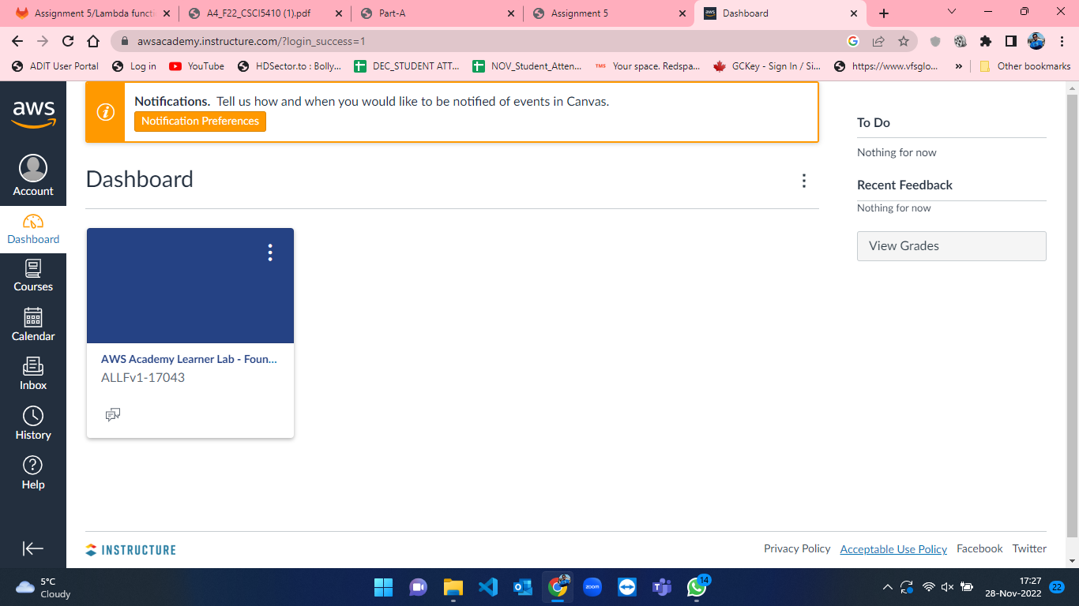

Figure 1: AWS Dashboard

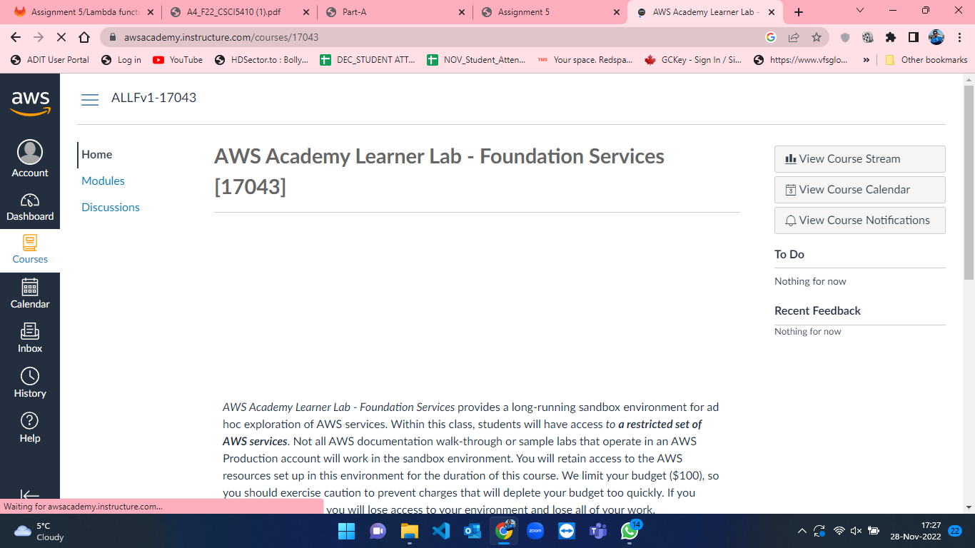

Figure 2: Homepage after course selection from dashboard in AWS.

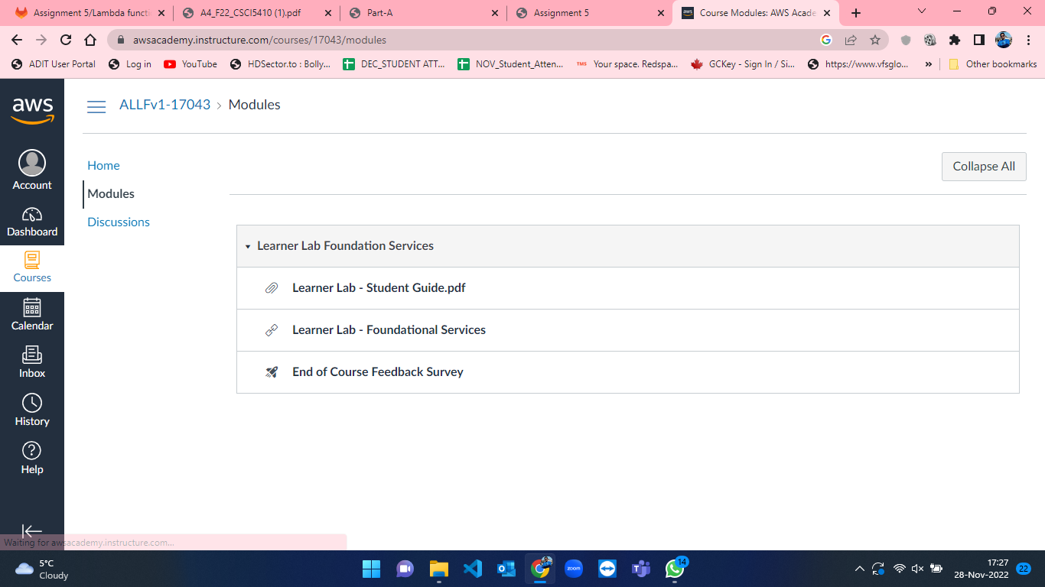

Figure 3: Modules page in AWS.

* After selecting “Learner Lab – Foundational Services”, the console page for the selected module is opened where the lab is currently not running. This can be seen in the below attached figure-4 where there is red mark besides AWS text. To start working on AWS and its services we must start a lab. So, click on “Start Lab” button to initiate lab. This can be seen in figure-5 where the lab is started, and the red mark turns to green besides AWS text.

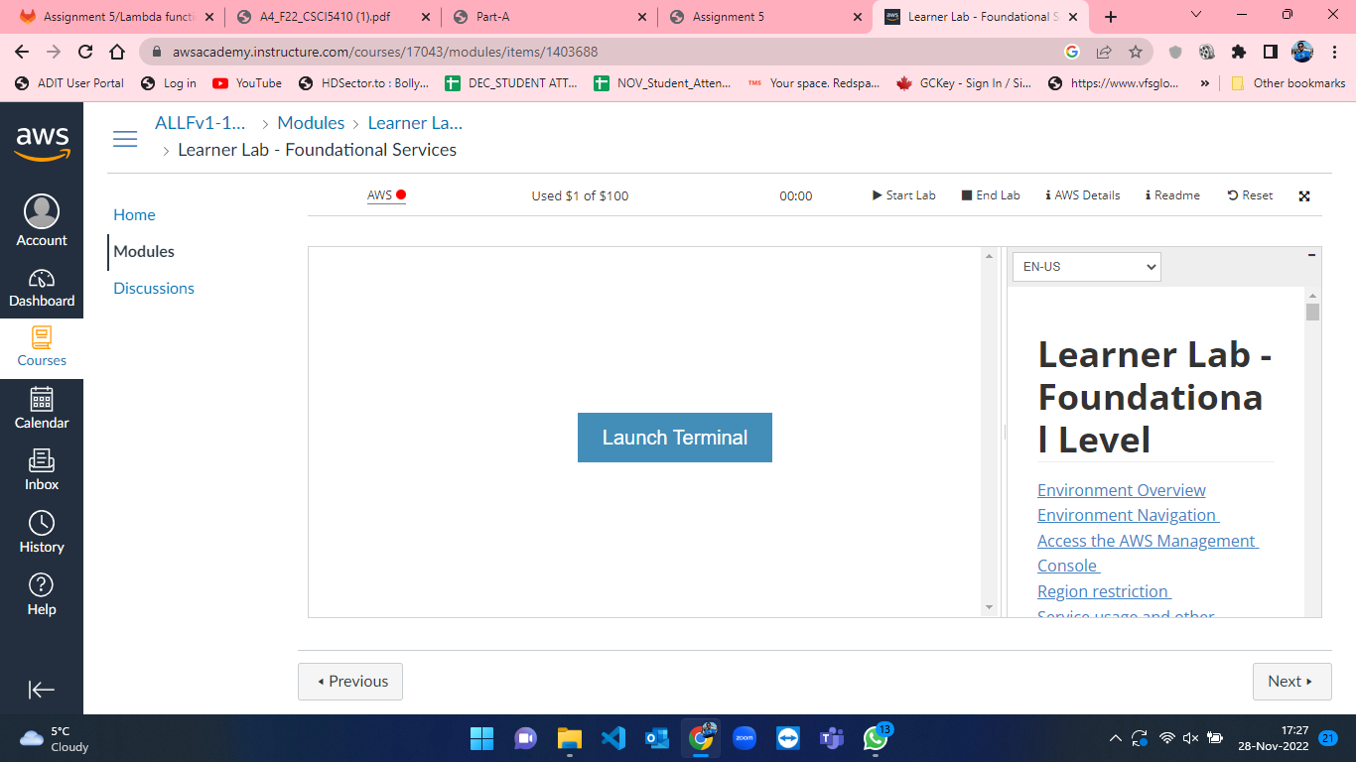

Figure 4: Lab not running in Modules page in AWS.

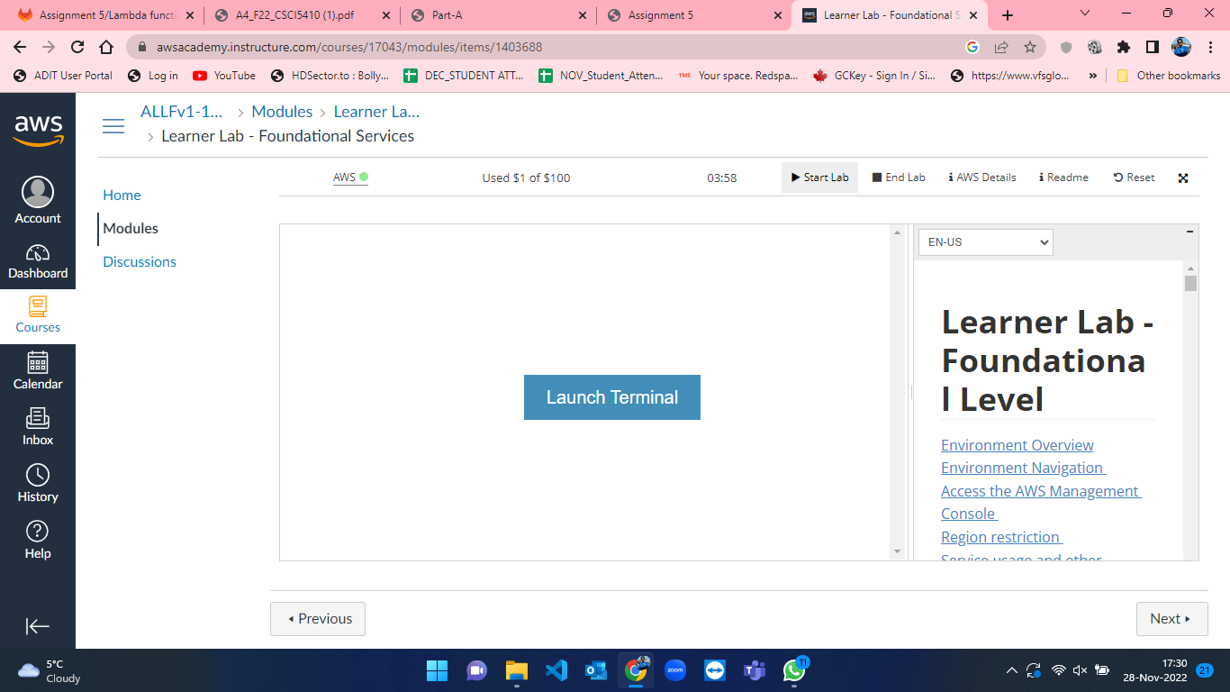

Figure 5: Lab started under Modules page in AWS.

* As soon as the lab started, click on AWS text beside the green mark which took me the AWS console home (Figure-6). From that now we can access the services of AWS.

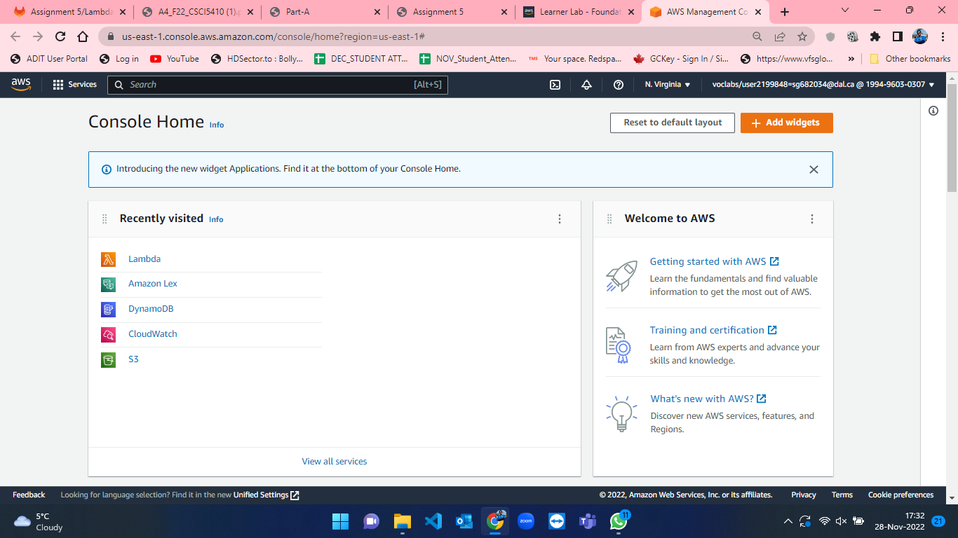

Figure 6: AWS Console Home.

* We have to create a Simple Queue Service so search SQS in the search bar at the top which will take us to SQS homepage. This is represented in figure-7 and figure-8.

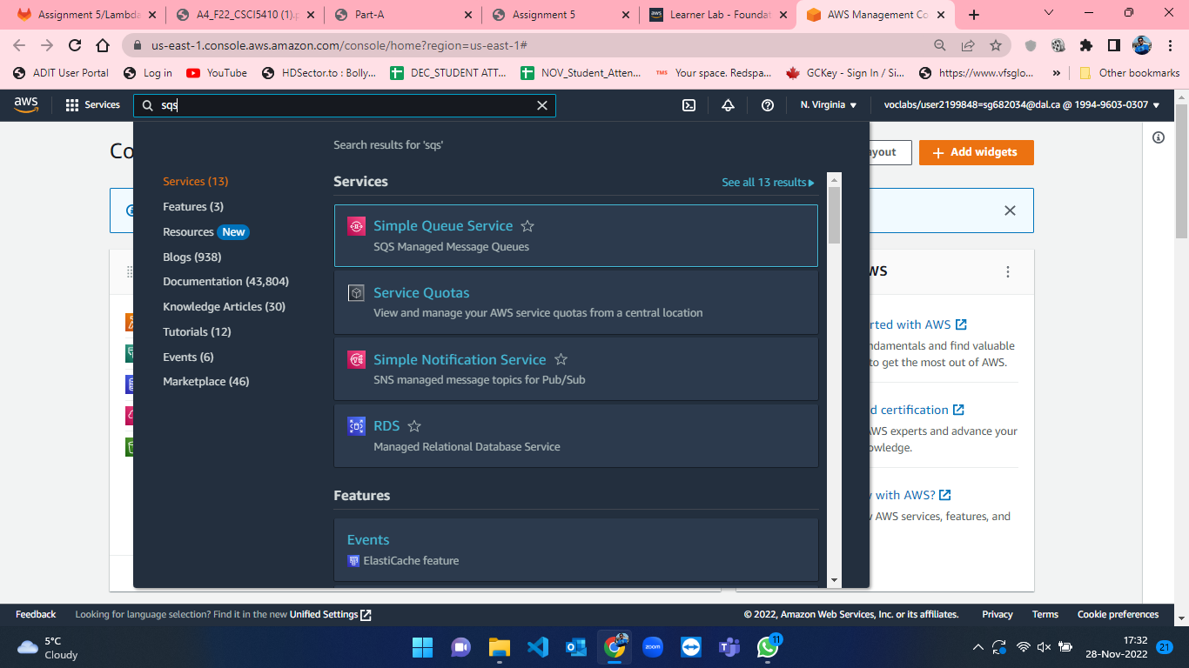

Figure 7: Searching for SQS in search bar from Console Home in AWS.

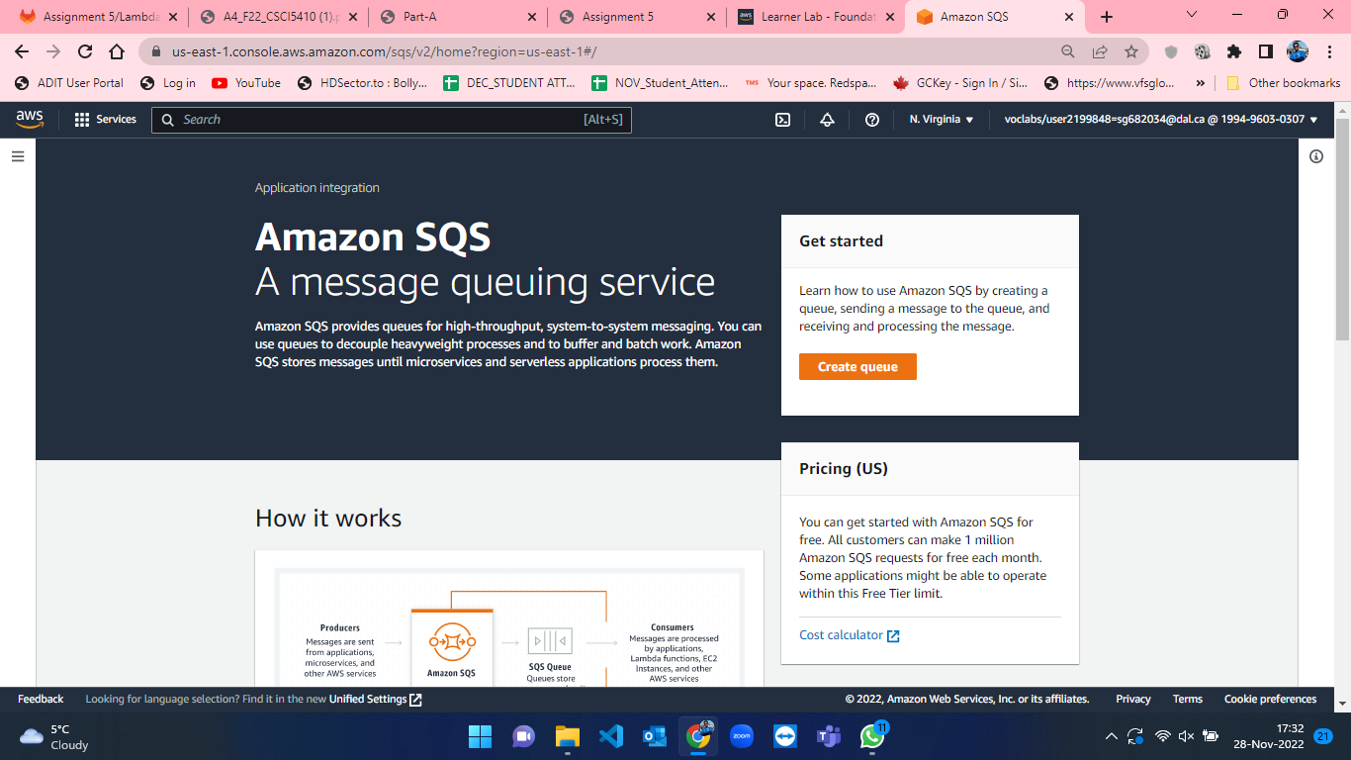

Figure 8: SQS homepage in AWS Console.

* From SQS homepage, we will click on “Create queue” button to create a new queue which will take us to create queue page. The process for creating queue is not tedious where I have selected standard queue option and named it as “assignmet4”. Other parameters kept default and click on “Create queue” button at bottom of the page which will create a SQS queue for us. The process for creating queue is shown from gifure-9 to figure-13.

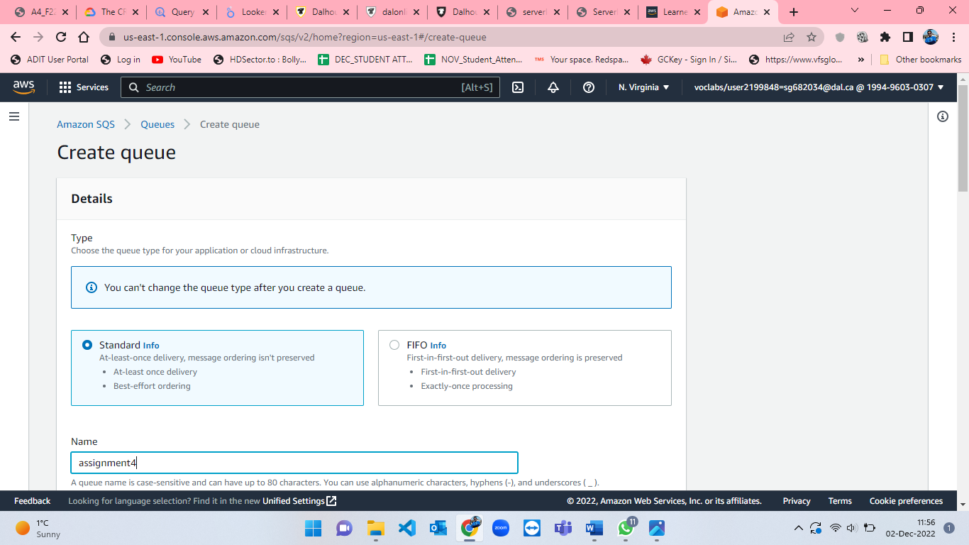

Figure 9: SQS create queue page - 1.

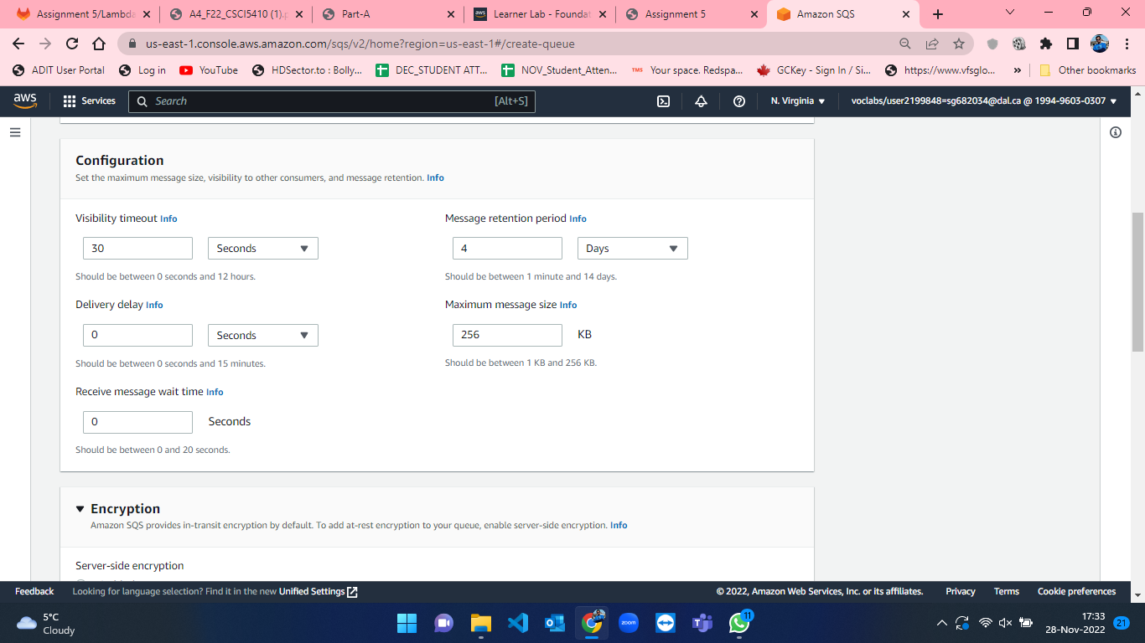

Figure 10: SQS create queue page - 2.

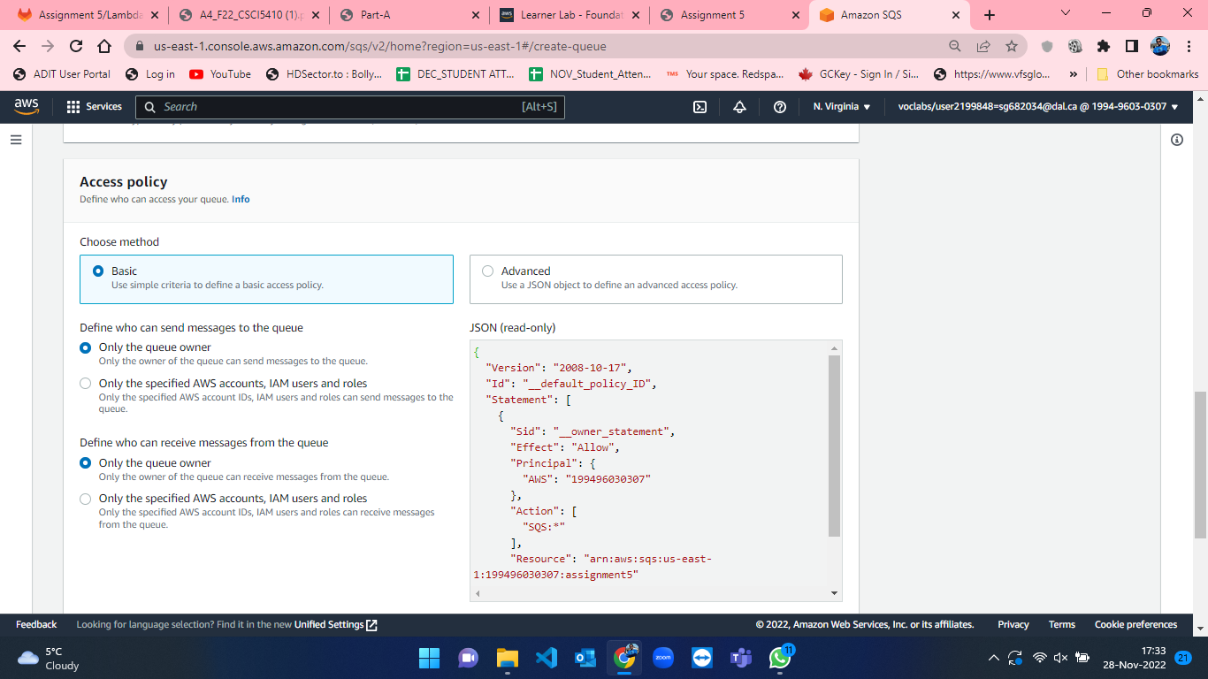

Figure 11: SQS create queue page - 3.

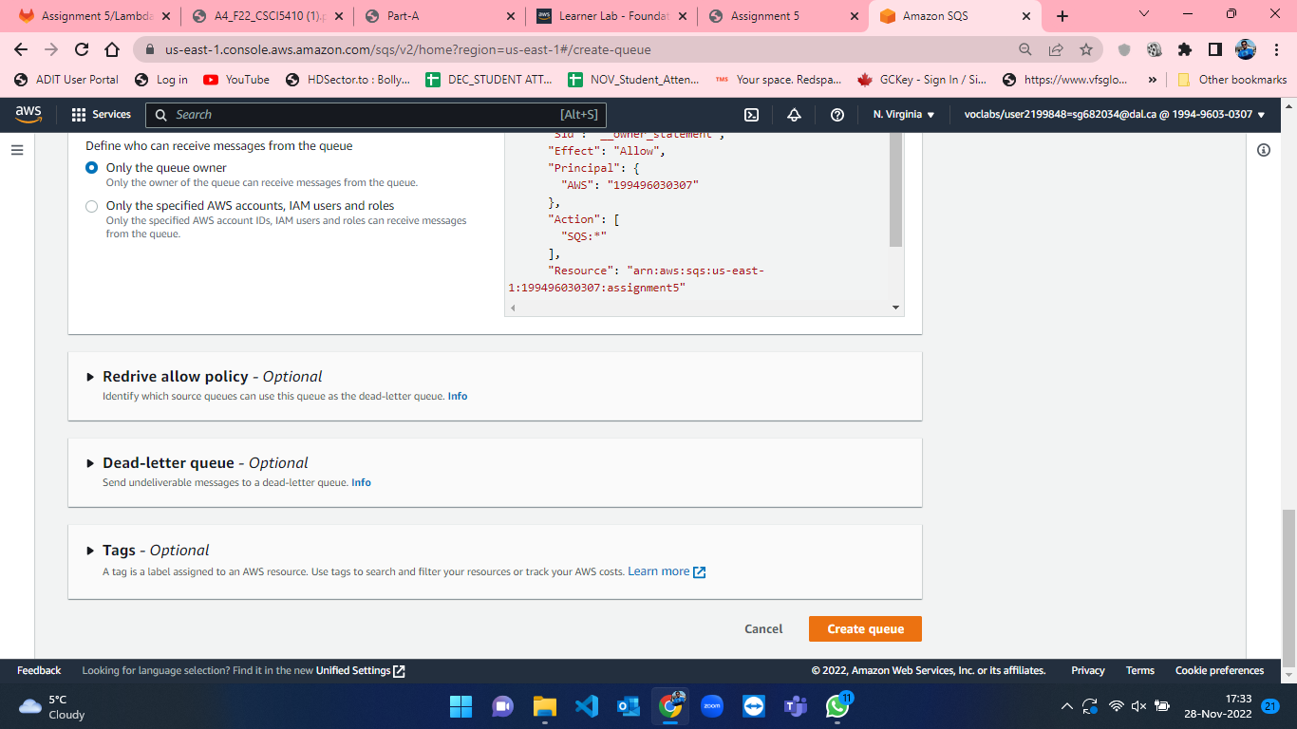

Figure 12: SQS create queue page - 4.

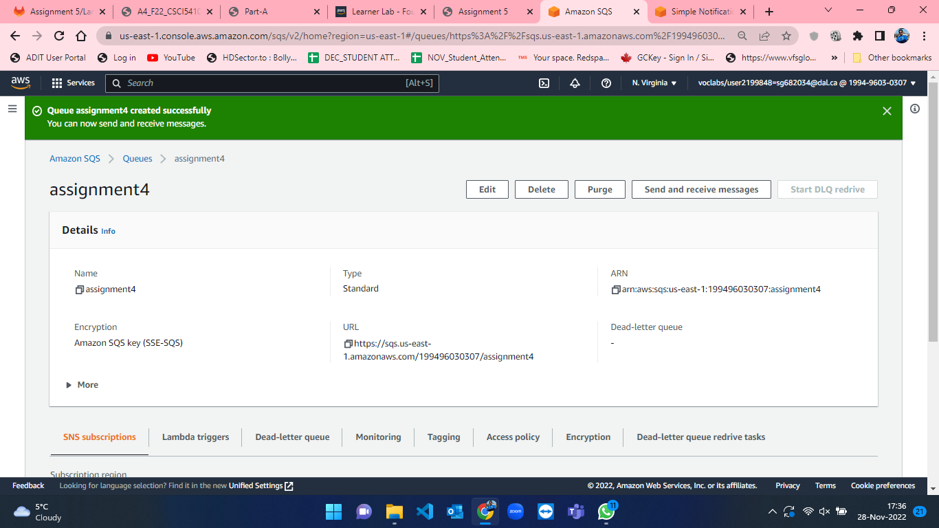

Figure 13: Successful creation of assignment4 queue.

* After creation of queue, I created maven project and developed a JAVA code to send random values of food combos, name of the user(here customers who ordered the food combo), time of order and order id to SQS queue. For using AWS credentials in maven project, I configured the credentials in environment variables and I have accessed those variables using System.getenv(). The result from the code is sent in JSON format. This procedure can be seen in the below attached figures from 14 to 17.

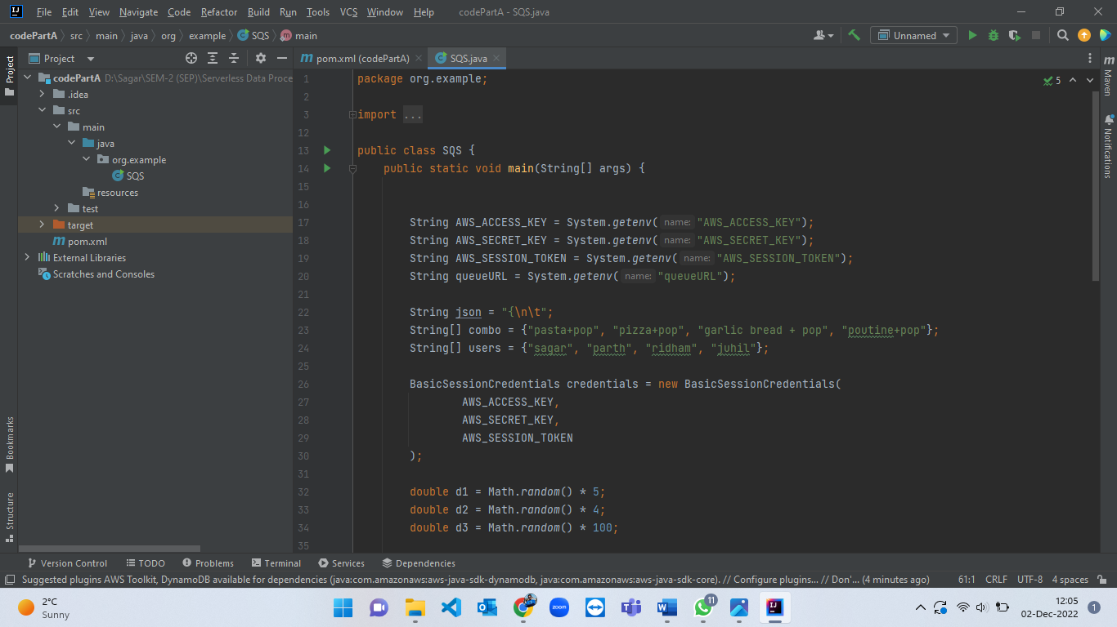

Figure 14: JAVA code for sending message in SQS queue part-1.

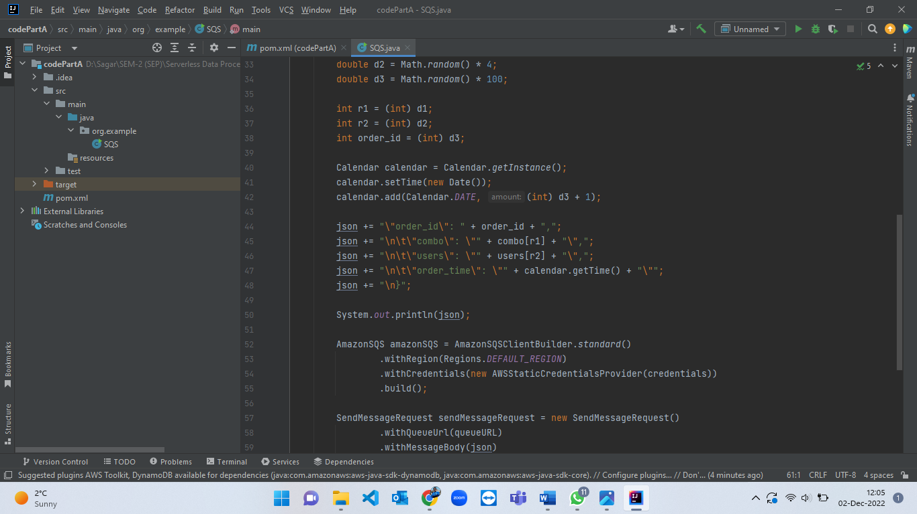

Figure 15: JAVA code for sending message in SQS queue part-2.

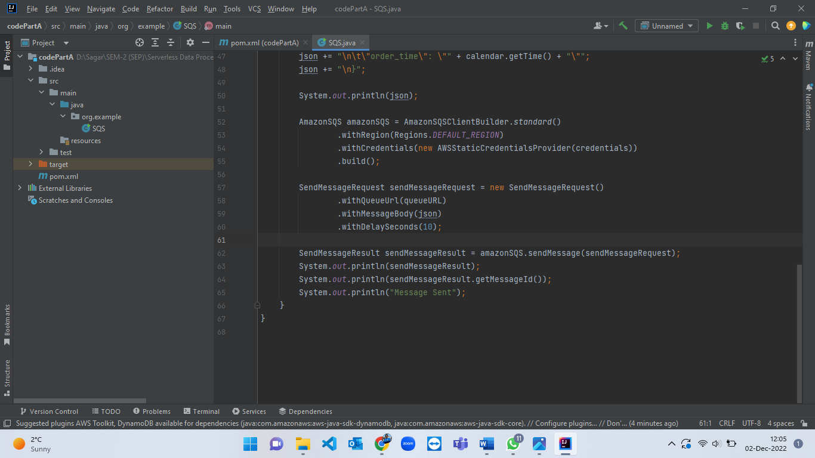

Figure 16: JAVA code for sending message in SQS queue part-3.

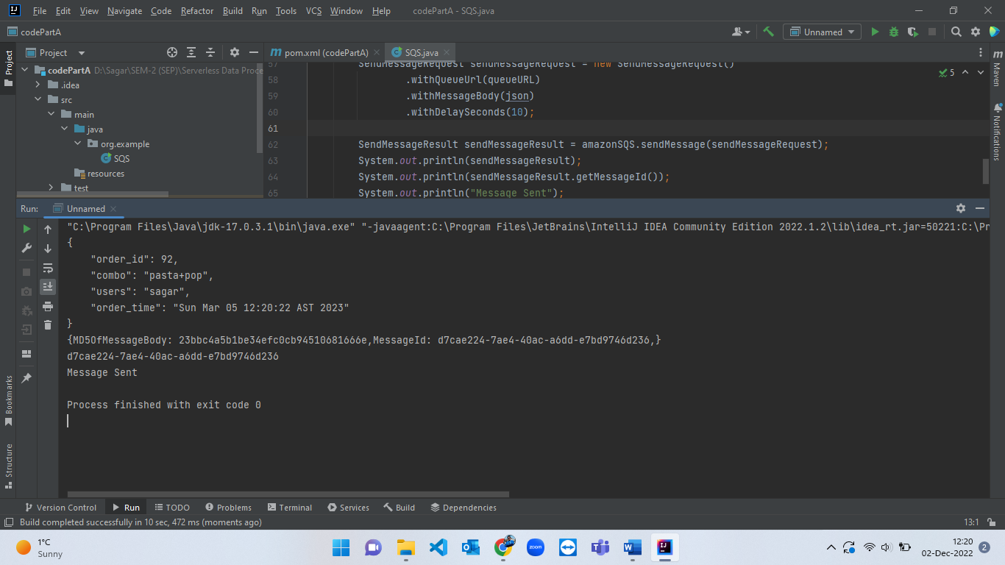

Figure 17: Execution logs from JAVA code displaying that message has been successfully sent to SQS.

When the message is successfully sent from JAVA code, now we have to verify that it is received in the SQS queue or not. For that, click on “Send and receive messages” option from SQS and then scroll to the bottom and click on ‘Poll for messages’ which will poll all the messages which are currently in a queue. The steps for viewing message in queue are shown from figure-18 to figure-/……….

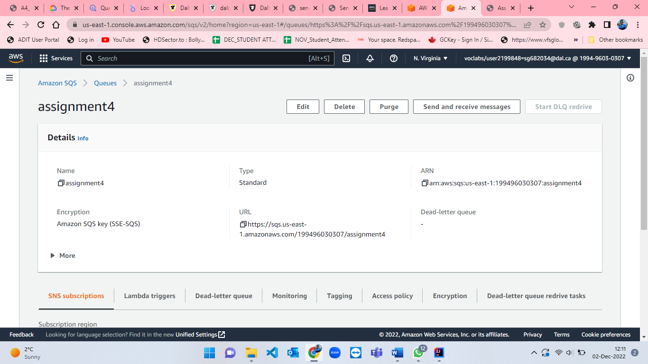

Figure 18: SQS page to select " Send and receive messages".

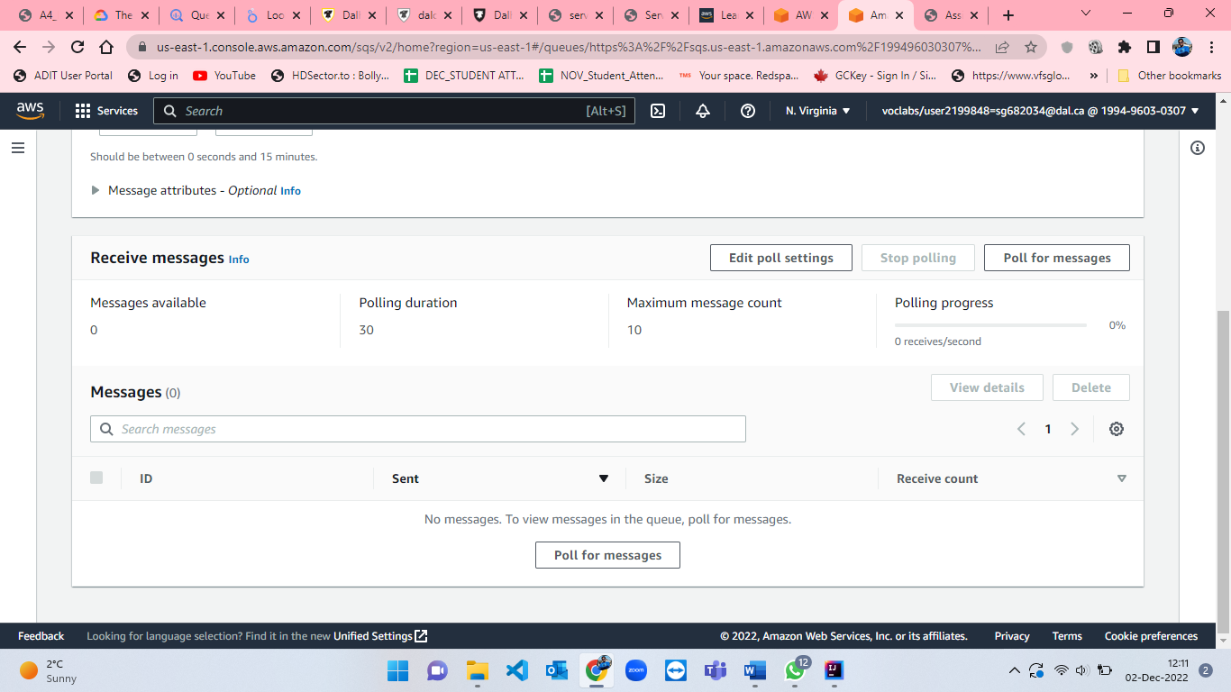

Figure 19: "Poll for messages" option from SQS.

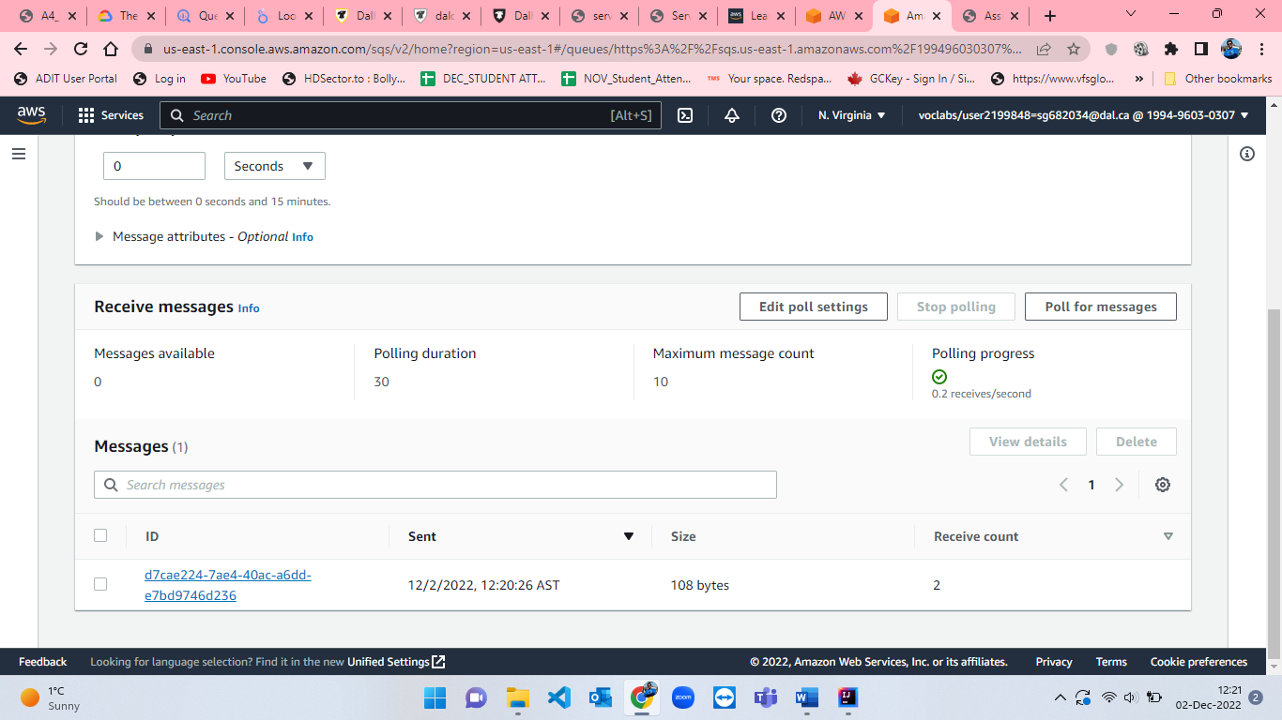

Figure 20: Message receivedd from JAVA code to SQS.

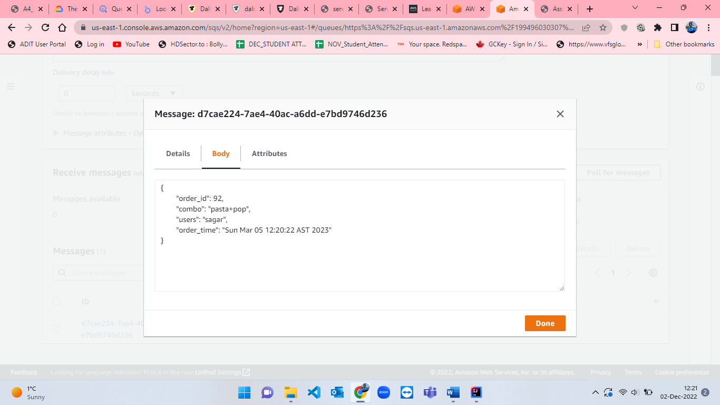

Figure 21: Displaying JSON format message received in SQS.

* After receiving message in SQS queue we have to create a SNS (simple notification service) subscription to notify the user by mail. For creating SNS subscription, search for SNS in the search bar which will take us to SNS homepage where we click on “Create topic” button. I named SNS topic as “a4sns” and selected “standard” type for sns. The other parameters while creating sns are set to default. The procedure for creating sns is shown from figure-22 to figure-26.

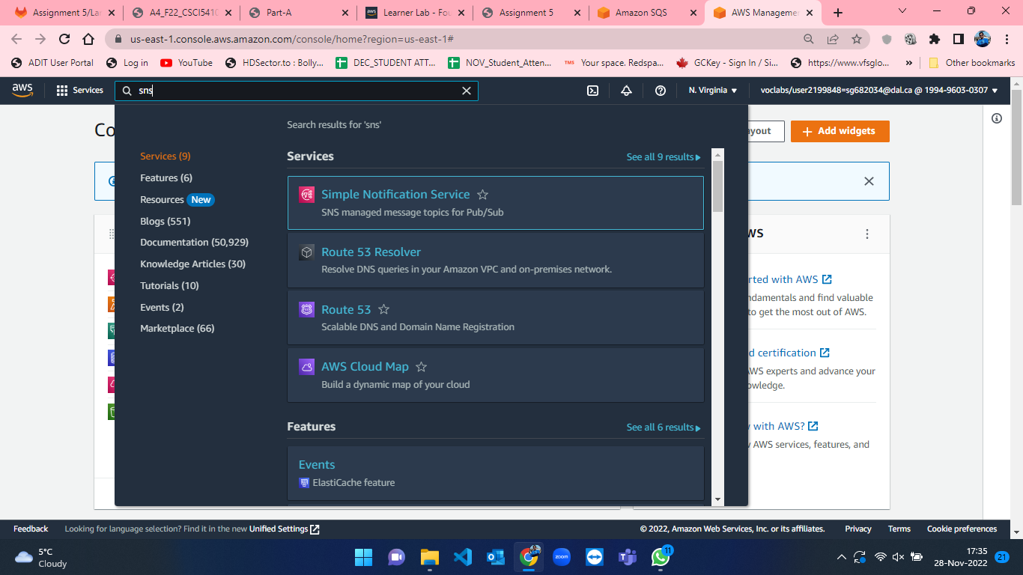

Figure 22: Searching for SNS in search bar from Console Home in AWS.

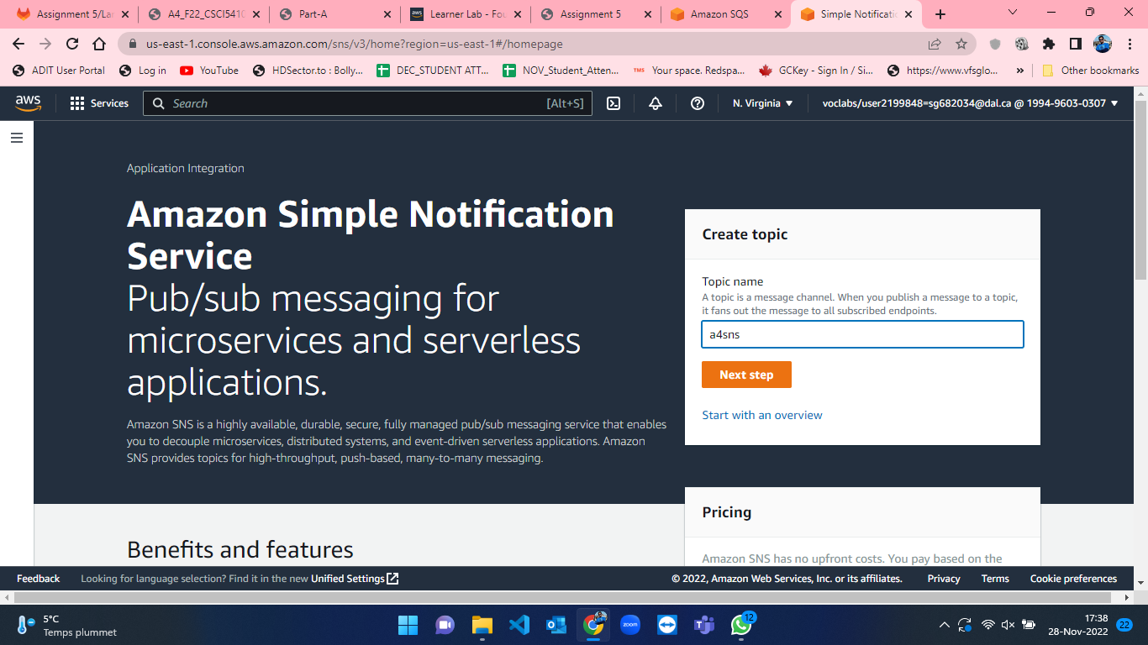

Figure 23: SNS homepage in AWS Console.

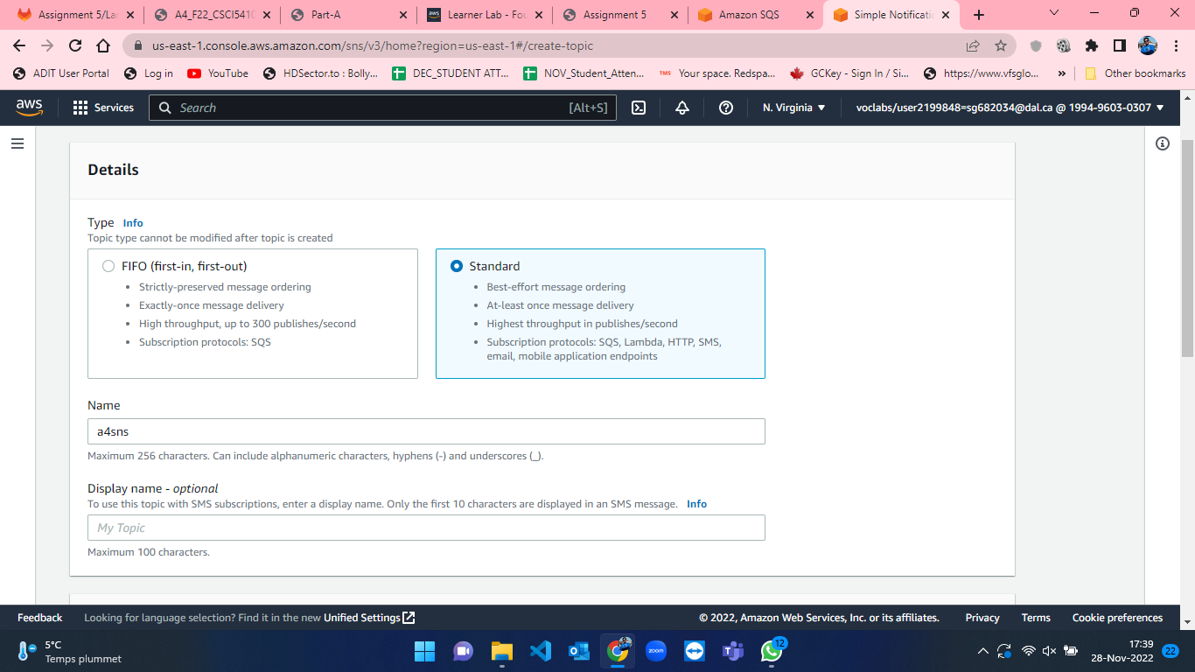

Figure 24: Create SNS part-1.

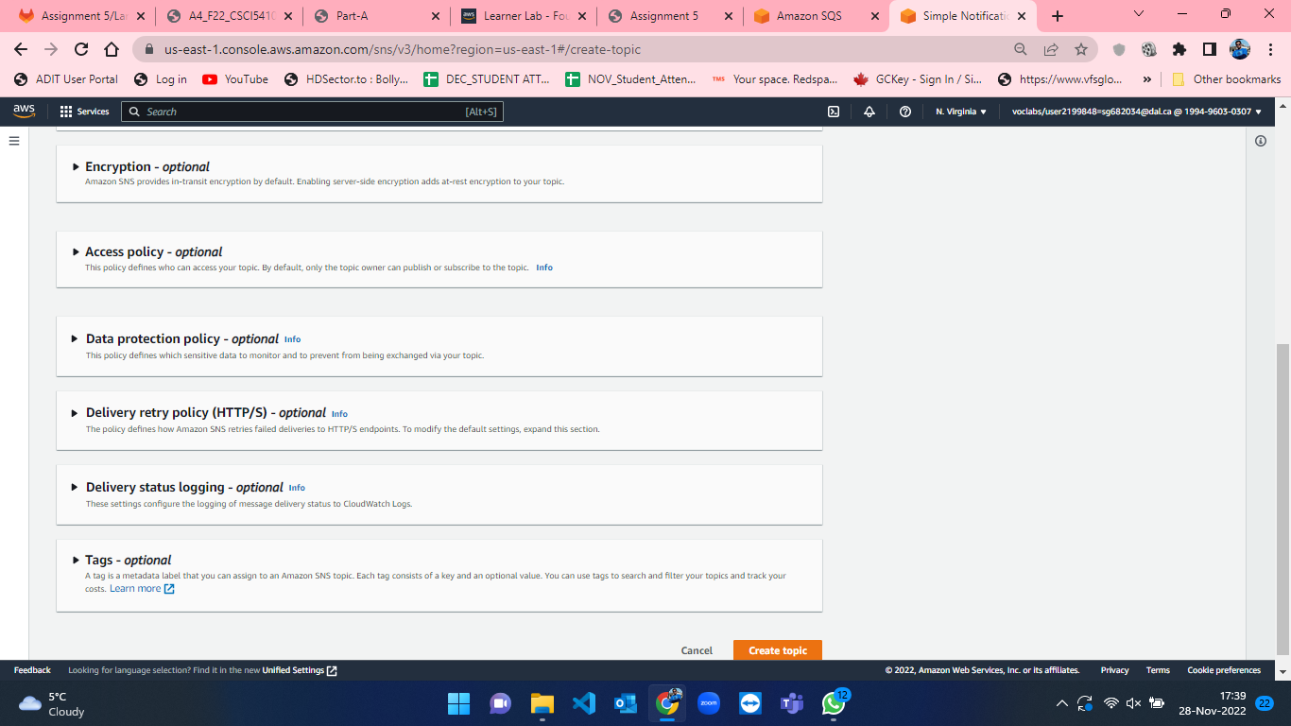

Figure 25: Create SNS part-2.

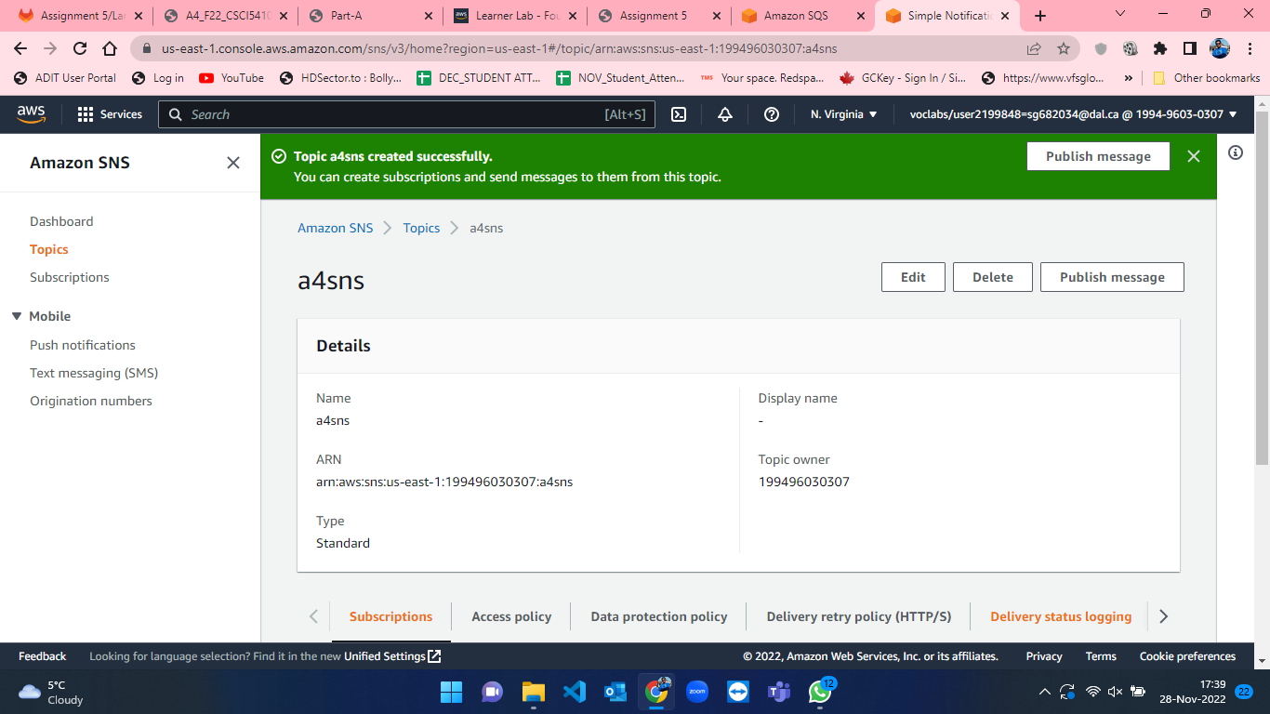

Figure 26: Successful creation of a4sns.

* As soon as SNS is created, we have to then create a subscription where we want to send the notification. For that, we have to scroll down from the sns topic which is recently created and then we will click on “Create subscription” button which is shown in figure-27. After that, we have to select topic ARN, Protocol type which I have selected email for email notification and endpoint where I specified my email address for getting notification. The other parameters are not changed and set to default only. The steps for subscription creation is shown from figure-27 to figure-30.

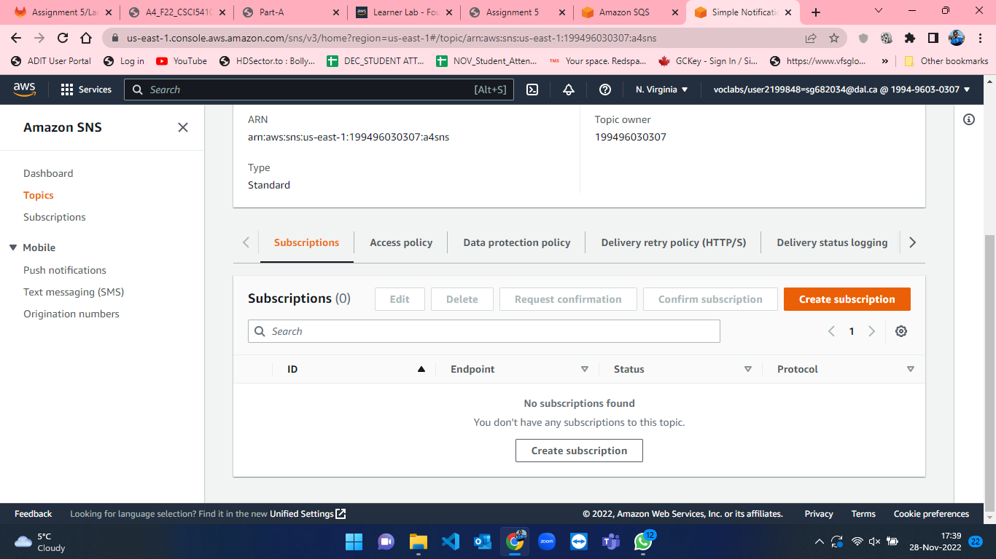

Figure 27: Create SNS subscription step-1.

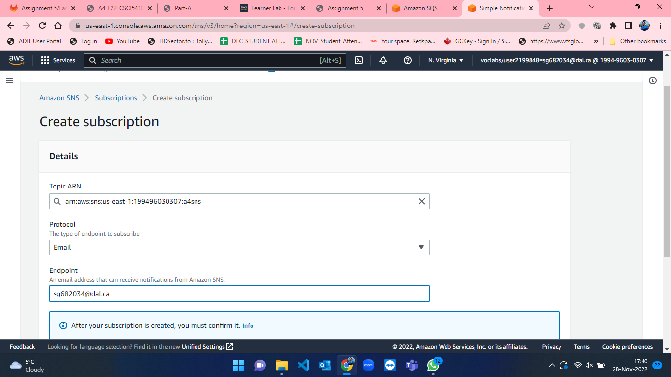

Figure 28: Create SNS subscription step-2.

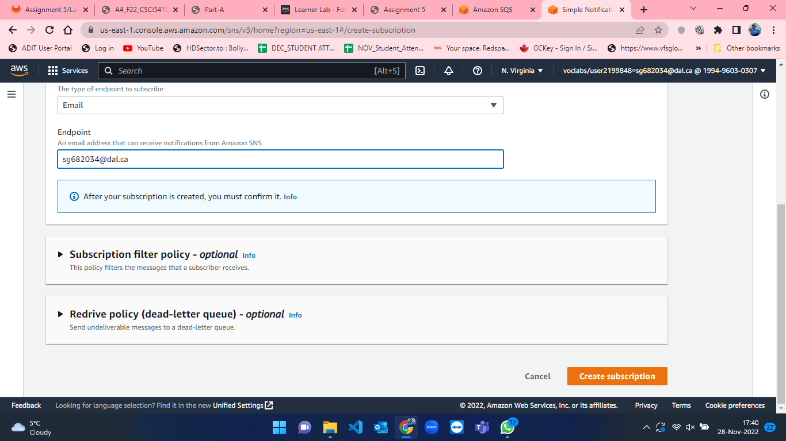

Figure 29: Create SNS subscription step-3.

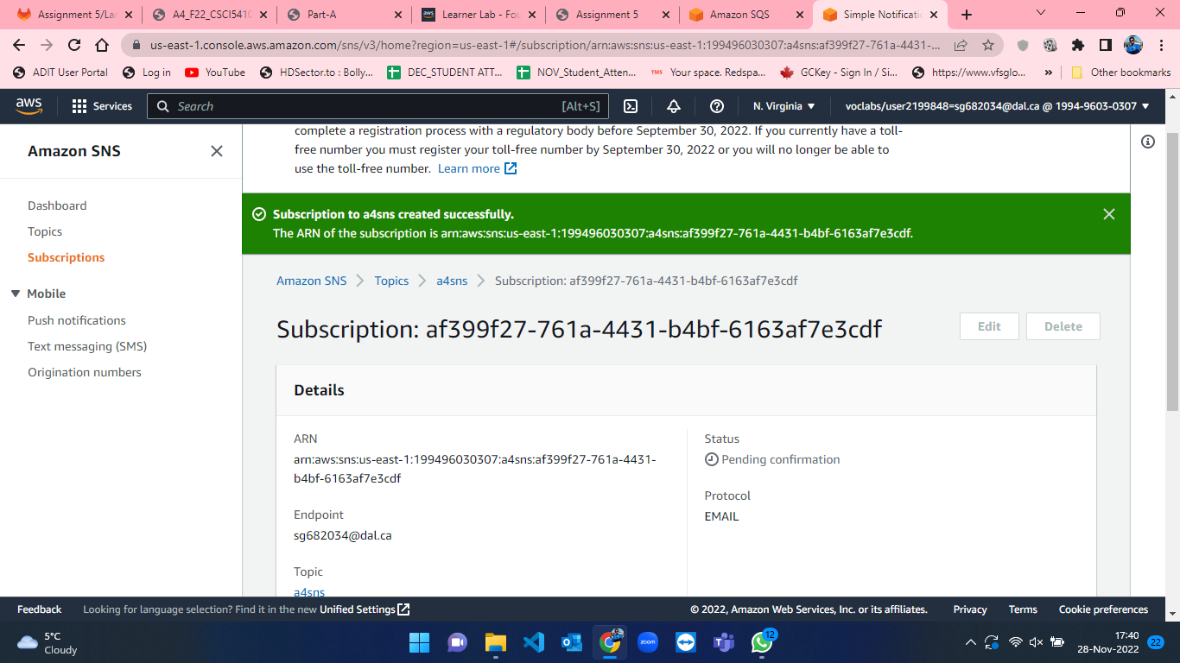

Figure 30: Successful creation of SNS subscription.

* Once the subscription is created, AWS will send the email to confirm the subscription for SNS. Click on “Confirm Subscription” link which is received in mail (figure-31 and figure-32).

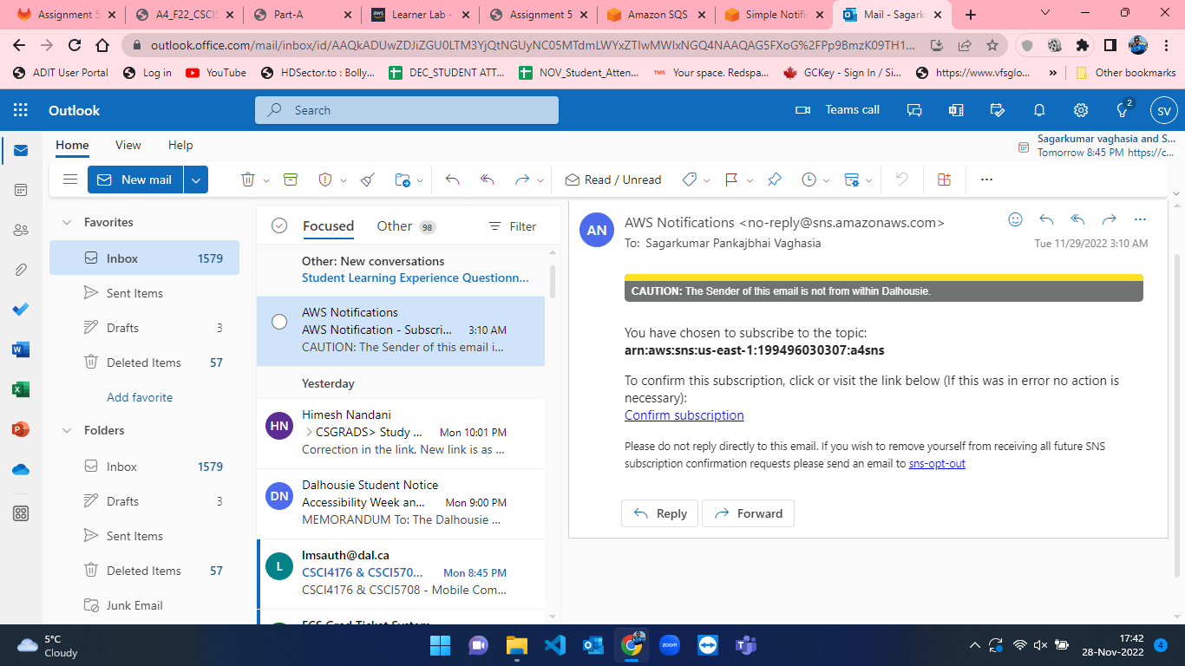

Figure 31: Confirm Subscription mail from AWS.

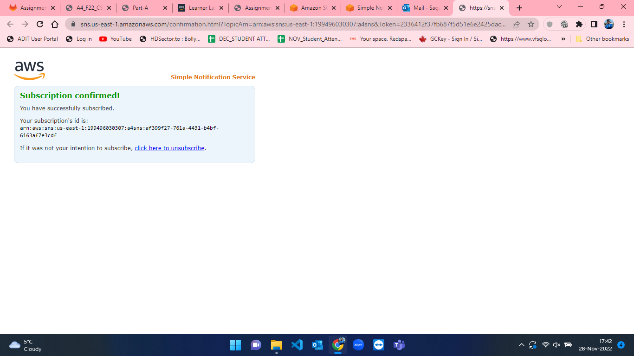

Figure 32: Subscription confirmation.

* Now, we have SQS queue where we can poll messages once it is sent also we have SNS subscription ready with our mail. So, we have to create a lambda function which will invoke when SQS will receive a message and will send notification to the mail that we have subscribed to using SNS. Therefore, I developed a lambda function and named it as “lambda-sqs” and selected “LabRole” when selecting execution role at the time of lambda function creation. The process of lambda function creation is visualized from figure-33 to figure-36.

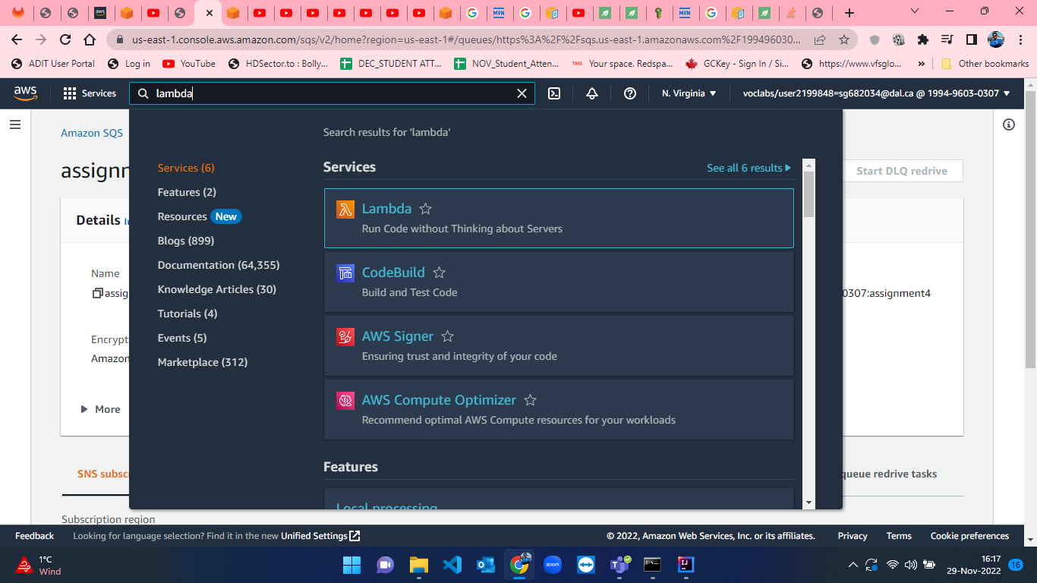

Figure 33: Lambda Function creation step-1.

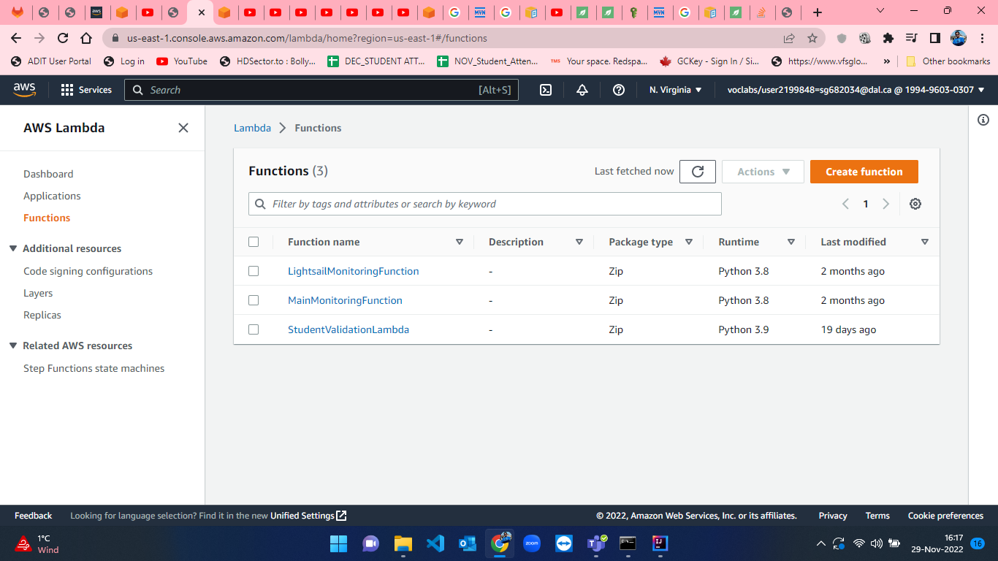

Figure 34: Lambda Function creation step-2.

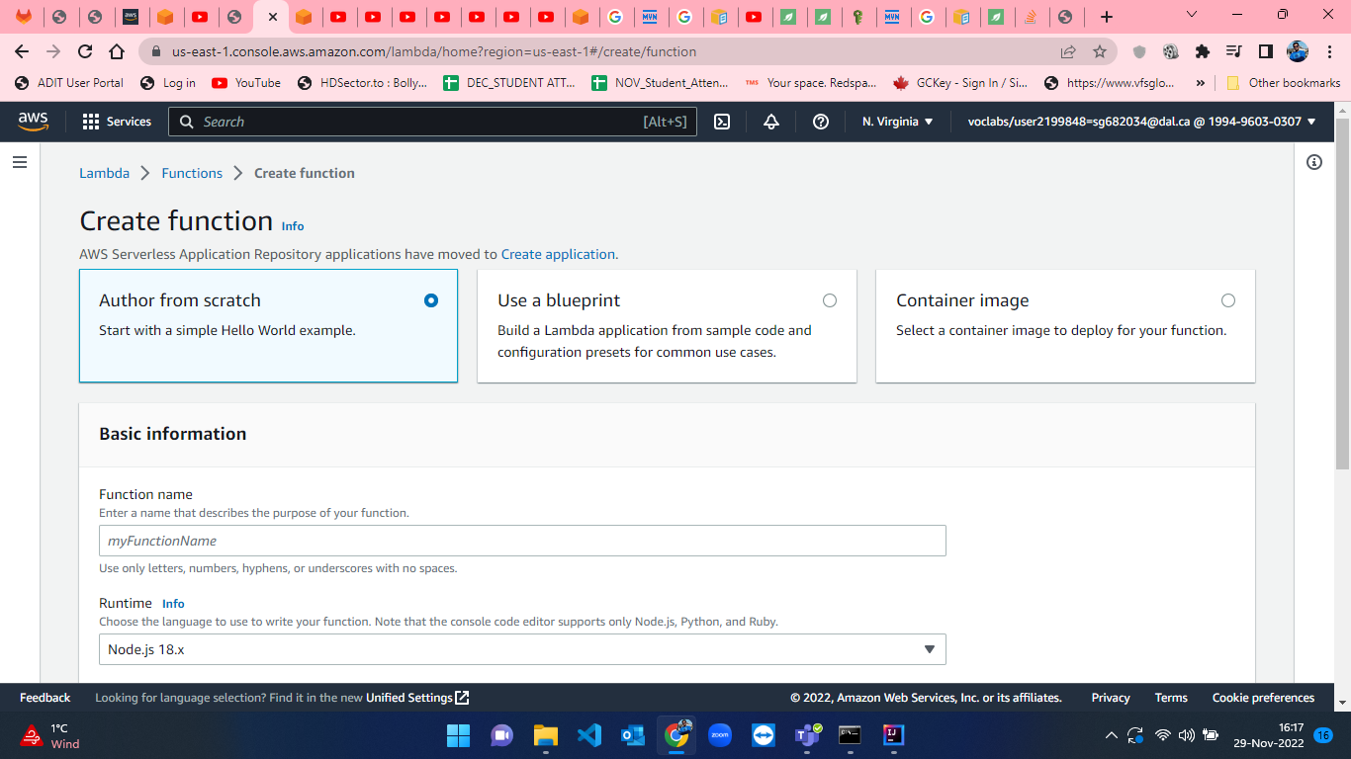

Figure 35: Lambda Function creation step-3.

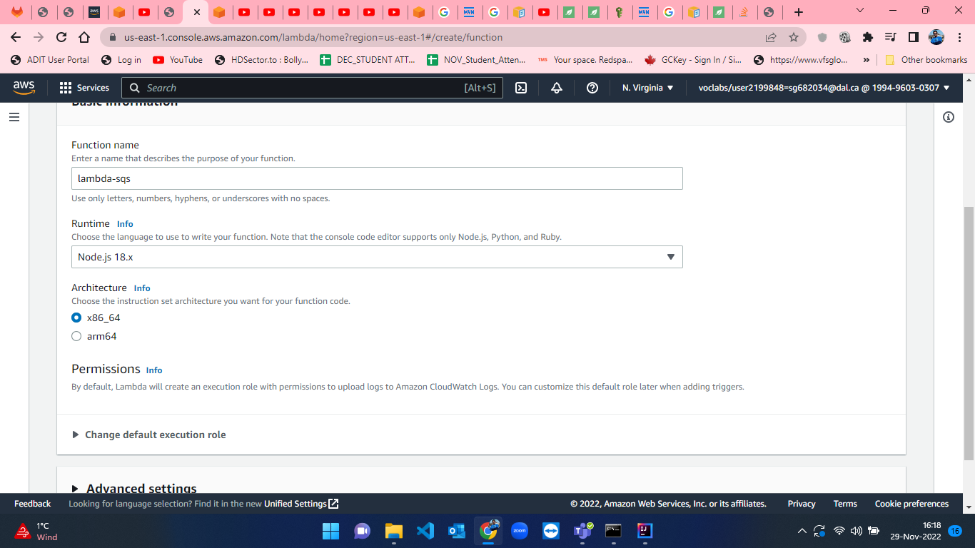

Figure 36: Lambda Function creation step-4.

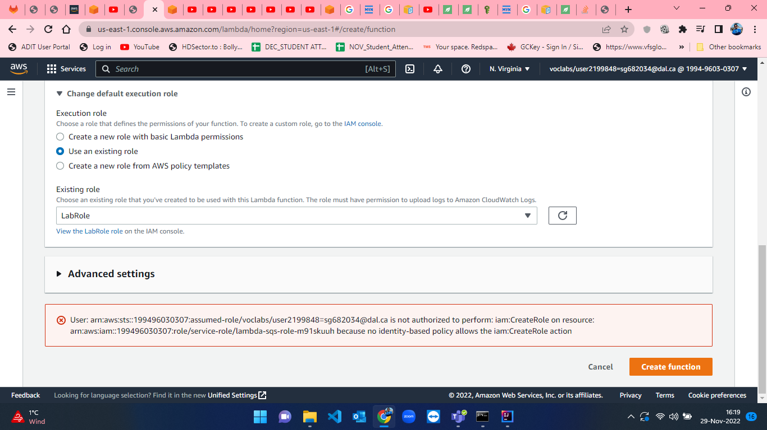

Figure 37: Lambda Function creation step-5.

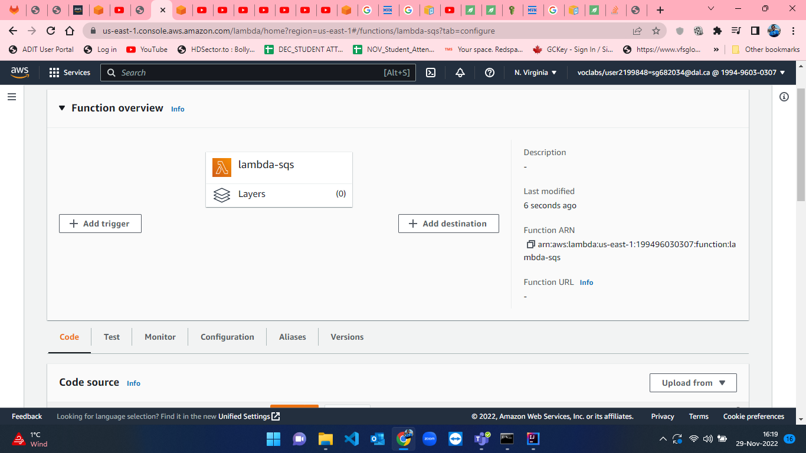

Figure 38: Lambda Function creation step-6.

* When the lambda function is created, we have to add trigger which can be done by clicking on “Add trigger” button from Function overview tab (figure-36). After that I searched for EventBridge (CloudWatch Events)” and I have created a trigger by setting “Create a new rule” and named that rule as “every5minutes” as we want notifications of new messages in queue after every 5 minutes. I selected “Schedule expression” and set the expression as “rate(5 minutes)” . Steps for adding trigger can be visualized in figure-37 and figure-38.

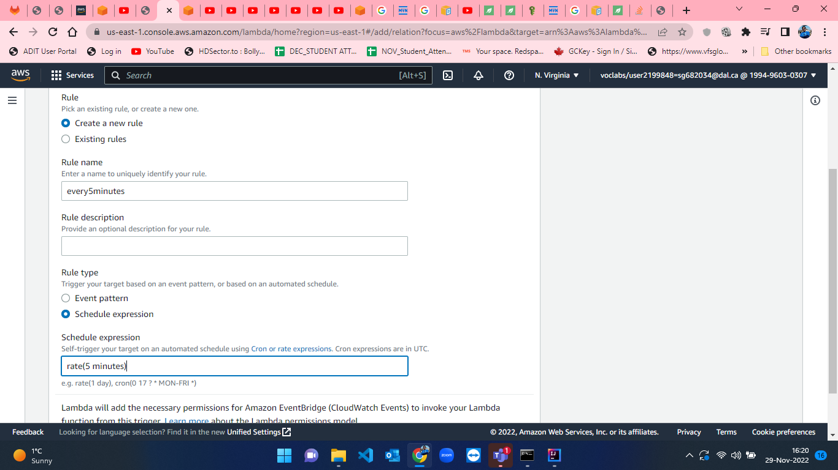

Figure 39: Adding trigger to lambda function.

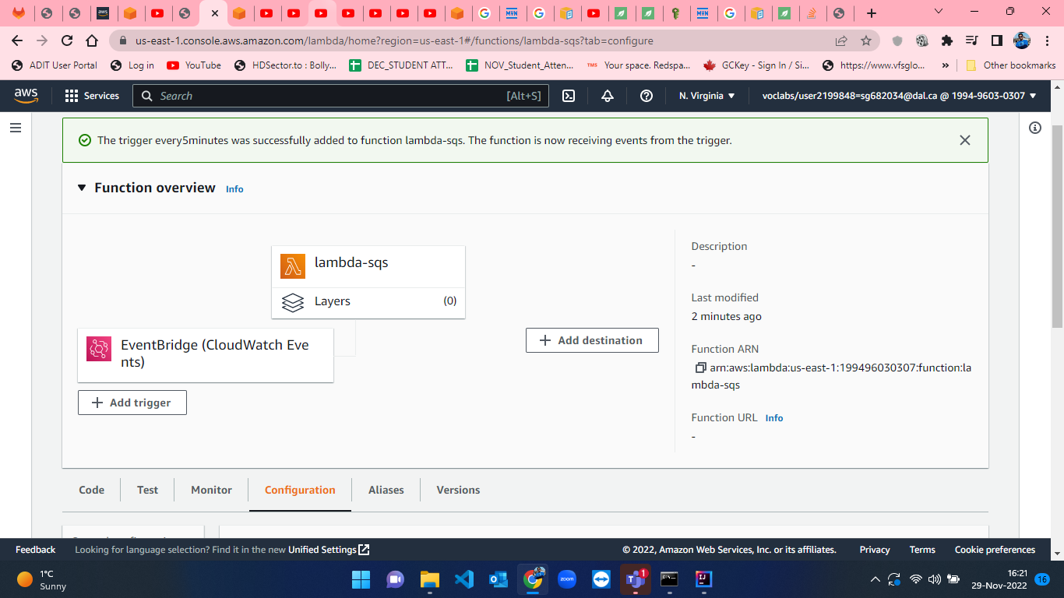

Figure 40: Successful trigger addition to lambda function.

* When the lambda function is ready with trigger, I developed a python script for sending notification by SNS which is received in message inside SQS queue. The lambda code is shown from figure-41 to figure-43.

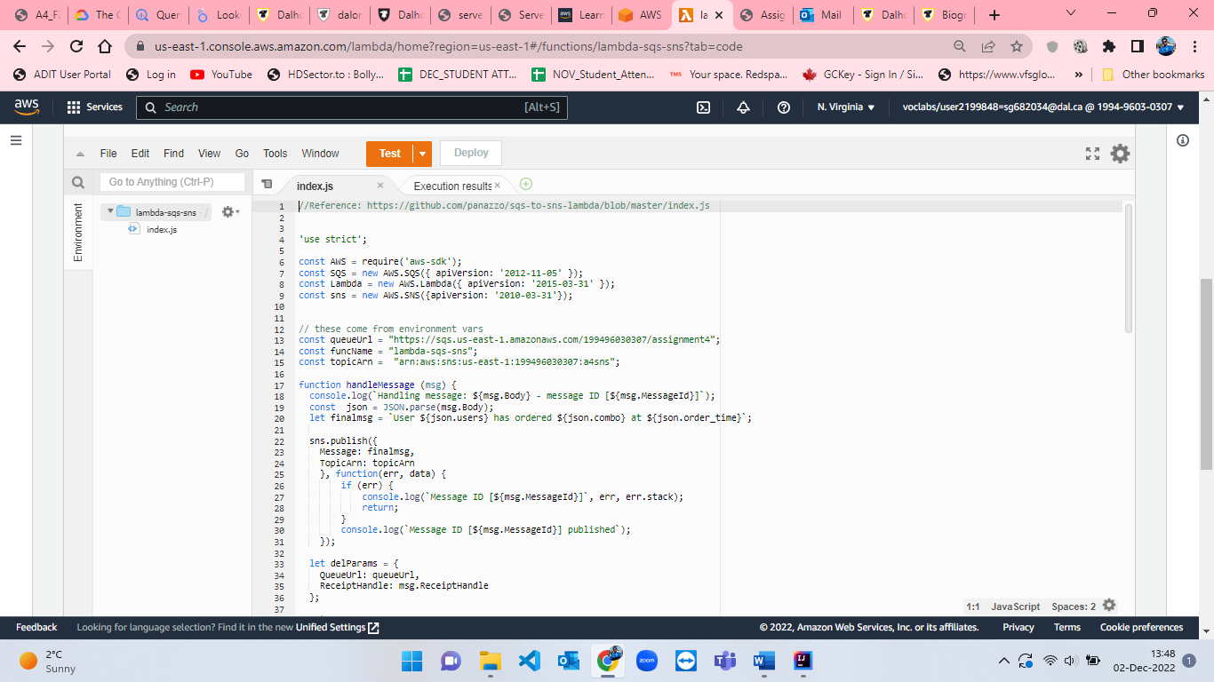

Figure 41: lambda function part-1.

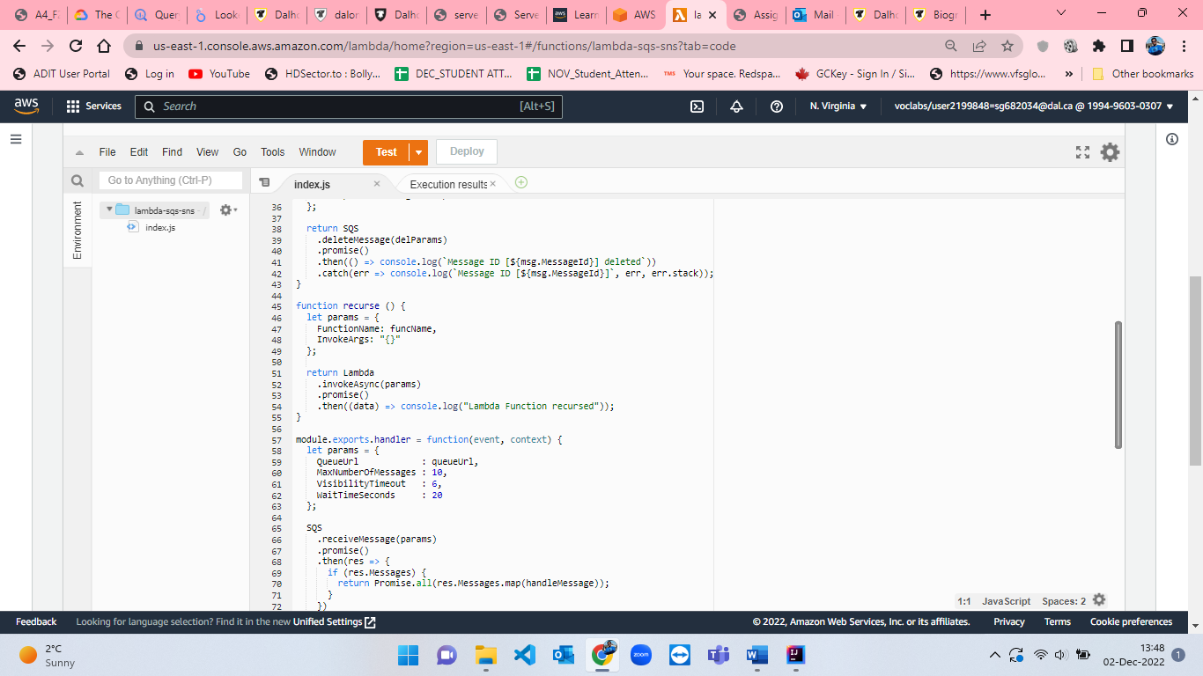

Figure 42: lambda function part-2.

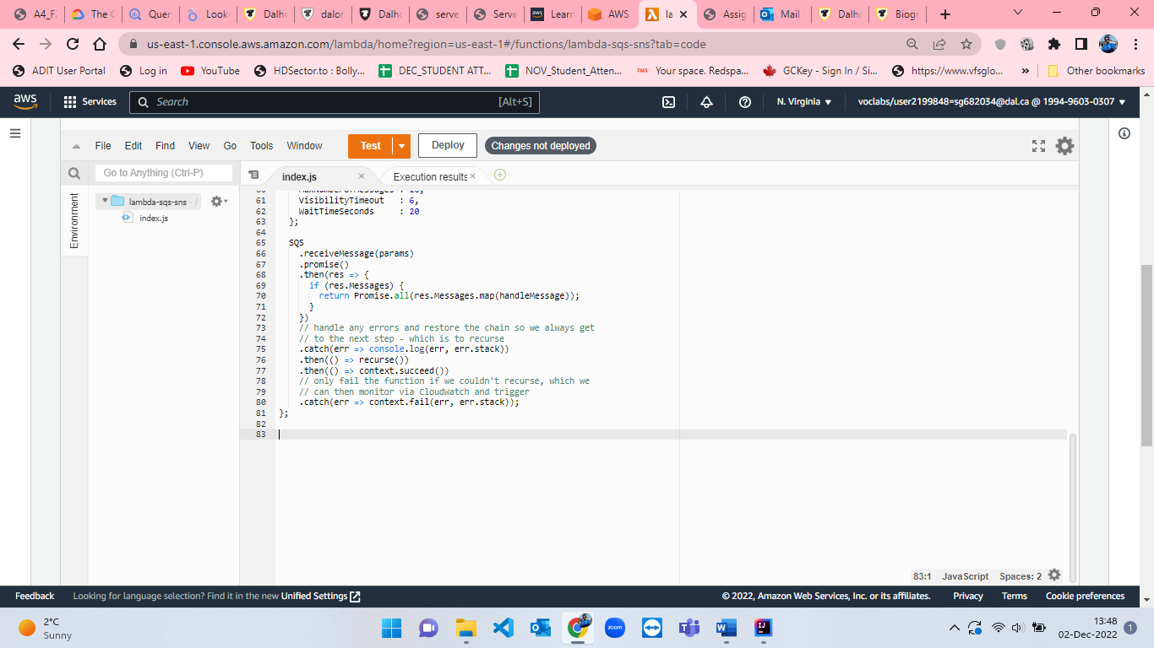

Figure 43: lambda function part-3.

* After development of code, I have created a Test environment for testing my code by clicking on “Test” button besides Deploy button which can be seen in figure-44 and named the event as “event” where I set the event sharing settings to “Private” and opted for template as “sqs-receive-message”.

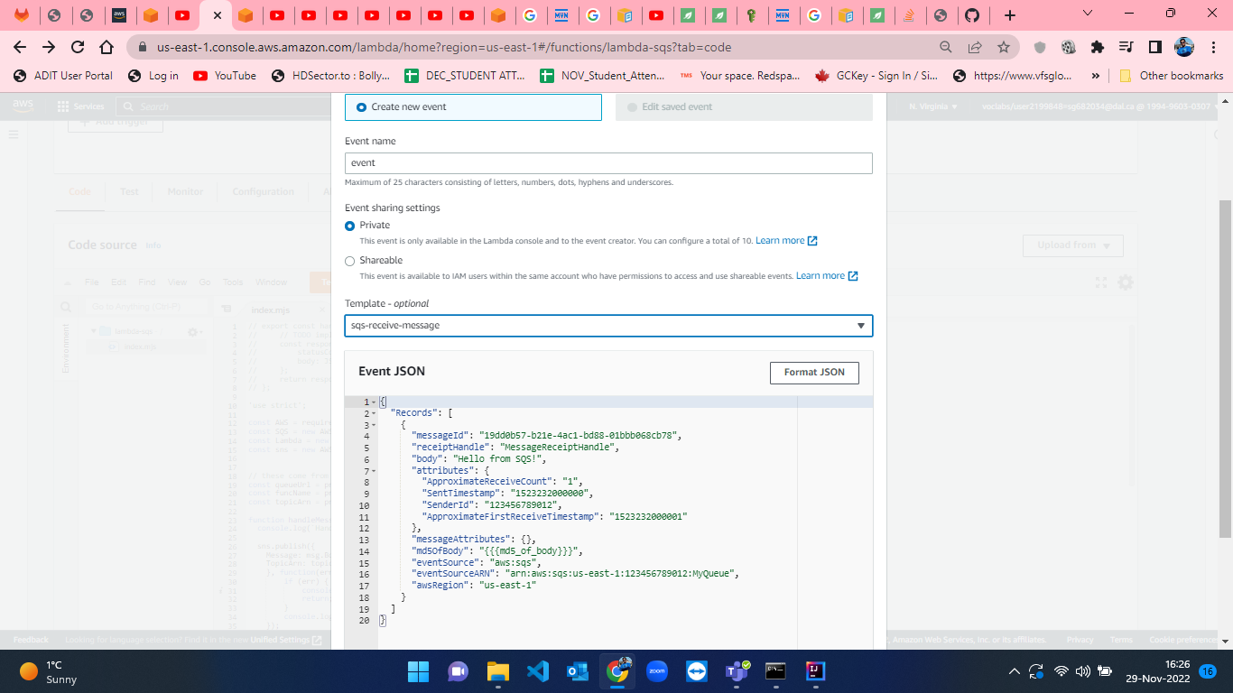

Figure 44: Event creation to test the lambda function.

* Afterwards, we have to test the lambda function and deploy the lambda function. After deployment, I have created 3 orders from the JAVA code randomly and sent it to SQS queue which will send notification to email in every 5 minutes. This is represented from figure-45 to figure-……

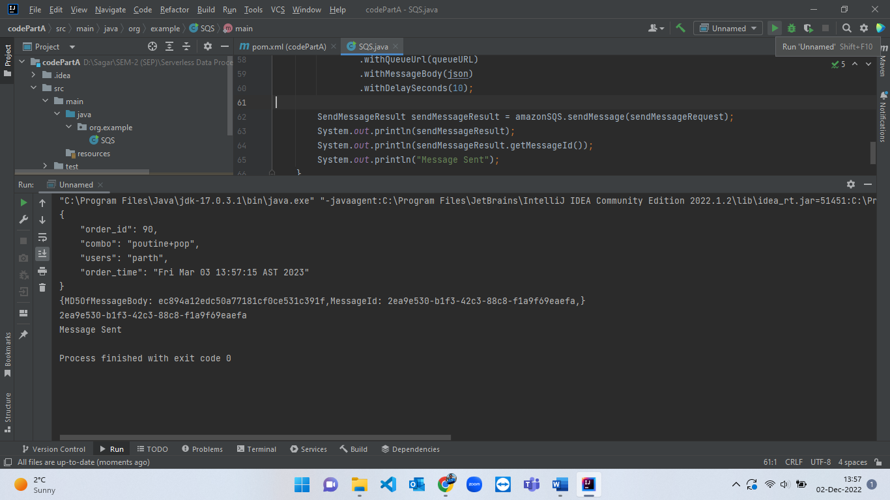

Figure 45: Random order creation - 1.

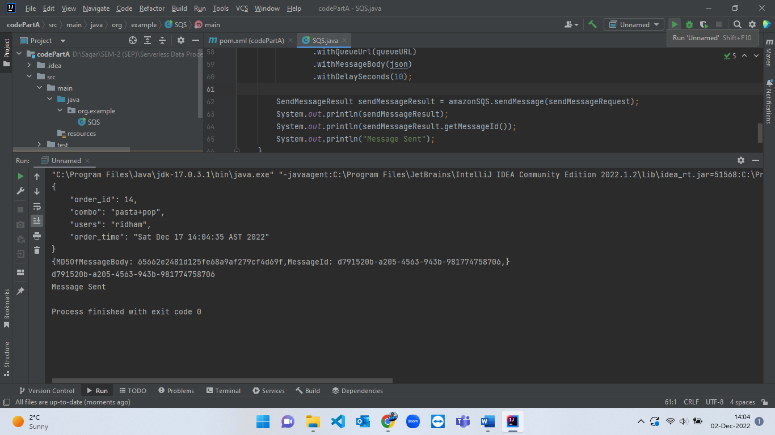

Figure 46: Random order creation - 2.

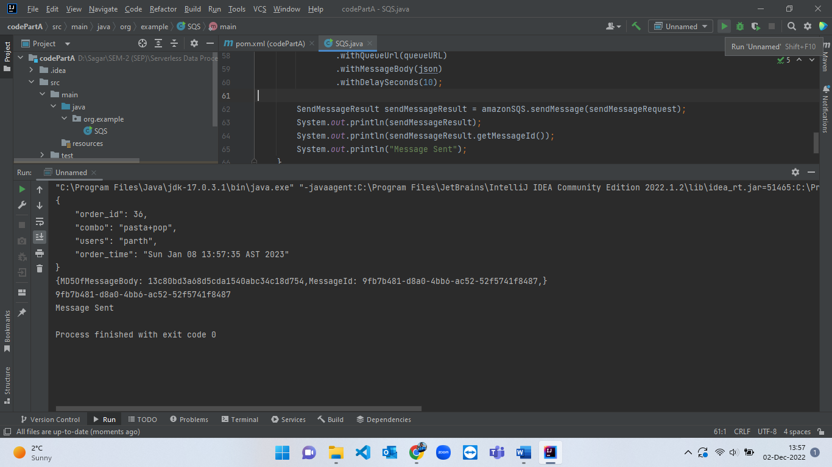

Figure 47: Random order creation - 3.

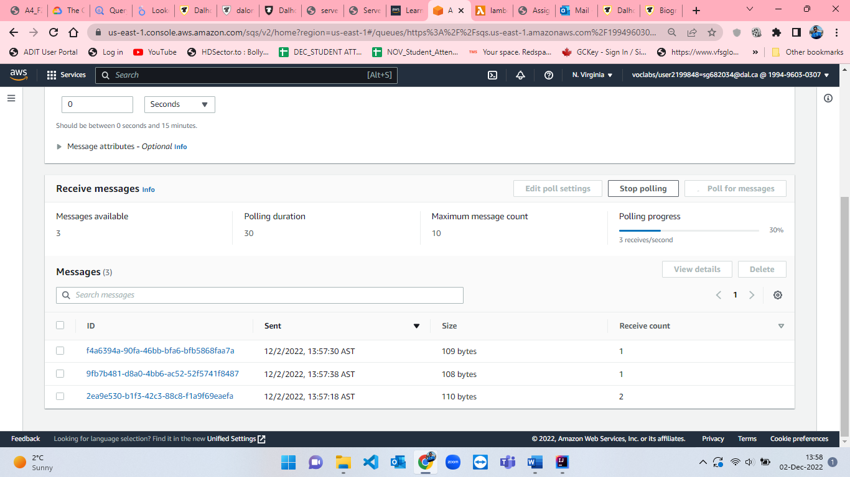

Figure 48: 3 orders messages polled in SQS queue.

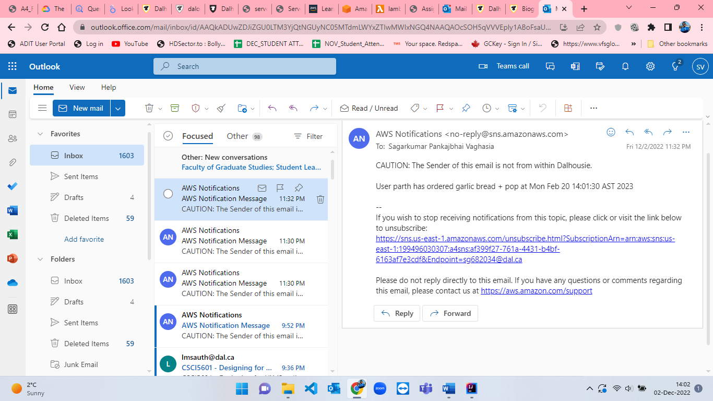

Figure 49: Email notification from SNS - 1.

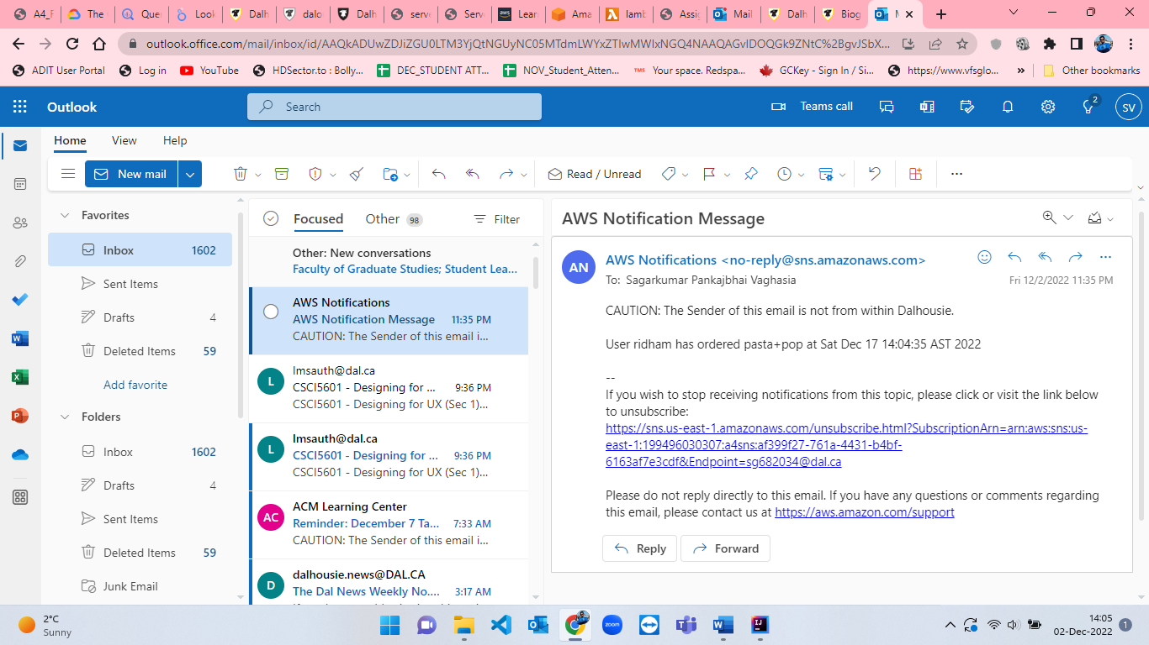

Figure 50: Email notification from SNS - 2.

**Code:**

**SQS.java**

package org.example;  
  
import com.amazonaws.auth.*;  
import com.amazonaws.regions.Regions;  
import com.amazonaws.services.sqs.AmazonSQS;  
import com.amazonaws.services.sqs.AmazonSQSClientBuilder;  
import com.amazonaws.services.sqs.model.SendMessageRequest;  
import com.amazonaws.services.sqs.model.SendMessageResult;  
import java.lang.*;  
import java.util.Calendar;  
import java.util.Date;  
  
public class SQS {  
 public static void main(String[] args) {  
  
  
 String AWS_ACCESS_KEY = System.*getenv*("AWS_ACCESS_KEY");  
 String AWS_SECRET_KEY = System.*getenv*("AWS_SECRET_KEY");  
 String AWS_SESSION_TOKEN = System.*getenv*("AWS_SESSION_TOKEN");  
 String queueURL = System.*getenv*("queueURL");  
  
 String json = "{\n\t";  
 String[] combo = {"pasta+pop", "pizza+pop", "garlic bread + pop", "poutine+pop"};  
 String[] users = {"sagar", "parth", "ridham", "juhil"};  
  
 BasicSessionCredentials credentials = new BasicSessionCredentials(  
 AWS_ACCESS_KEY,  
 AWS_SECRET_KEY,  
 AWS_SESSION_TOKEN  
 );  
  
 double d1 = Math.*random*() * 5;  
 double d2 = Math.*random*() * 4;  
 double d3 = Math.*random*() * 100;  
  
 int r1 = (int) d1;  
 int r2 = (int) d2;  
 int order_id = (int) d3;  
  
 Calendar calendar = Calendar.*getInstance*();  
 calendar.setTime(new Date());  
 calendar.add(Calendar.*DATE*, (int) d3 + 1);  
  
 json += "\"order_id\": " + order_id + ",";  
 json += "\n\t\"combo\": \"" + combo[r1] + "\",";  
 json += "\n\t\"users\": \"" + users[r2] + "\",";  
 json += "\n\t\"order_time\": \"" + calendar.getTime() + "\"";  
 json += "\n}";  
  
 System.*out*.println(json);  
  
 AmazonSQS amazonSQS = AmazonSQSClientBuilder.*standard*()  
 .withRegion(Regions.*DEFAULT_REGION*)  
 .withCredentials(new AWSStaticCredentialsProvider(credentials))  
 .build();  
  
 SendMessageRequest sendMessageRequest = new SendMessageRequest()  
 .withQueueUrl(queueURL)  
 .withMessageBody(json)  
 .withDelaySeconds(10);  
  
 SendMessageResult sendMessageResult = amazonSQS.sendMessage(sendMessageRequest);  
 System.*out*.println(sendMessageResult);  
 System.*out*.println(sendMessageResult.getMessageId());  
 System.*out*.println("Message Sent");  
 }  
}

**Lambda function : index.js**

//Reference: https://github.com/panazzo/sqs-to-sns-lambda/blob/master/index.js  
  
'use strict';  
  
const AWS = require('aws-sdk');  
const SQS = new AWS.SQS({ apiVersion: '2012-11-05' });  
const Lambda = new AWS.Lambda({ apiVersion: '2015-03-31' });  
const sns = new AWS.SNS({apiVersion: '2010-03-31'});  
  
const queueUrl = "https://sqs.us-east-1.amazonaws.com/199496030307/assignment4";  
const funcName = "lambda-sqs-sns";  
const topicArn = "arn:aws:sns:us-east-1:199496030307:a4sns";  
  
function handleMessage (msg) {  
 console.log(`Handling message: ${msg.Body} - message ID [${msg.MessageId}]`);  
 const json = JSON.parse(msg.Body);  
 let finalmsg = `User ${json.users} has ordered ${json.combo} at ${json.order_time}`;  
   
 sns.publish({  
 Message: finalmsg,  
 TopicArn: topicArn  
 }, function(err, data) {  
 if (err) {  
 console.log(`Message ID [${msg.MessageId}]`, err, err.stack);  
 return;  
 }  
 console.log(`Message ID [${msg.MessageId}] published`);  
 });  
  
 let delParams = {  
 QueueUrl: queueUrl,  
 ReceiptHandle: msg.ReceiptHandle  
 };  
   
 return SQS  
 .deleteMessage(delParams)  
 .promise()  
 .then(() => console.log(`Message ID [${msg.MessageId}] deleted`))  
 .catch(err => console.log(`Message ID [${msg.MessageId}]`, err, err.stack));  
}  
  
function recurse () {  
 let params = {   
 FunctionName: funcName,  
 InvokeArgs: "{}"  
 };  
   
 return Lambda  
 .invokeAsync(params)  
 .promise()  
 .then((data) => console.log("Lambda Function recursed"));  
}  
  
module.exports.handler = function(event, context) {  
 let params = {  
 QueueUrl : queueUrl,  
 MaxNumberOfMessages : 10,  
 VisibilityTimeout : 6,  
 WaitTimeSeconds : 20  
 };  
   
 SQS  
 .receiveMessage(params)  
 .promise()  
 .then(res => {  
 if (res.Messages) {  
 return Promise.all(res.Messages.map(handleMessage));  
 }  
 })  
 // handle any errors and restore the chain so we always get  
 // to the next step - which is to recurse  
 .catch(err => console.log(err, err.stack))  
 .then(() => recurse())  
 .then(() => context.succeed())  
 // only fail the function if we couldn't recurse, which we  
 // can then monitor via CloudWatch and trigger   
 .catch(err => context.fail(err, err.stack));  
};

**References:**